Drilling Well Basis of Design (BOD)

EXECUTIVE SUMMARY
The Alpha-07 Well Basis of Design (BOD) defines the engineering criteria and minimum technical requirements for the detailed design, drilling, evaluation, and initial completion of the Alpha-07 development well in Alpha Field. The well is intended to validate and develop the remaining hydrocarbon potential within the mature Alpha Field, with successful drilling and production performance providing the technical basis for potential subsequent development wells. Alpha Field has an estimated OOIP of approximately 21.66 MMSTB, cumulative production of approximately 6.48 MMSTB, and a current water cut of approximately 99%, indicating remaining hydrocarbon potential despite the mature stage of field development.

Alpha-07 is classified as a directional development producer targeting the Bara, Bama, Raja, and Prima reservoir intervals. The well will be drilled using a J-type trajectory with a planned total depth of approximately 5,312 ft MD and horizontal displacement of approximately 2,437 ft. The J-type profile is selected primarily due to the relatively large offset between the available surface location and the subsurface target, providing a more practical trajectory than an S-type profile while reducing trajectory complexity and facilitating drilling, casing, logging, and completion operations. The proposed trajectory is designed to penetrate the complete target reservoir sequence and terminate within the lower productive stratigraphic interval without unnecessary penetration into the underlying basement.

The two-string casing concept is selected based on offset well evaluation, shallow gas assessment, and historical drilling performance in the Alpha Field. Available offset data indicate low shallow-gas potential, with relatively low total gas readings and no significant historical gas influx or gas bubble events during drilling operations. Accordingly, the two-string configuration is considered technically feasible for Alpha-07. Offset evaluation showed relatively low total gas readings in the equivalent shallow interval and no historical indication of significant gas influx or gas bubbles during drilling operations. The preliminary casing design consists of 9-5/8 in., 36 ppf, K55 BTC surface casing and 7 in., 23 ppf, K55 BTC production casing. A KCl Polymer Water-Based Mud system will be used as the primary drilling fluid system. The preliminary design basis applies approximately 8.7–9.0 ppg mud weight for the upper hole section and approximately 9.0–9.8 ppg for the production section, subject to refinement based on the final PPFG model and real-time well conditions. Cementing will utilize Class G cement with a minimum 12.5 ppg lead slurry and 15.8 ppg tail slurry. Lightweight cement and fiber are retained as contingency options in the event of significant losses during drilling or cement placement. The primary anticipated drilling hazards are sloughing shale, gumbo and tight-hole tendencies in the upper formations, followed by loss circulation, differential sticking, stuck pipe, logging tool stop, and casing running difficulties across the deeper reservoir section. These hazards have been identified based on historical offset well performance and will be addressed through appropriate mud weight management, hole-cleaning practices, hydraulics control, torque-and-drag monitoring, loss prevention measures, and operational contingency planning. The key anticipated drilling hazards include sloughing, loss circulation during drilling and cementing, stuck pipe, differential sticking, logging stop, and casing stop.

Formation evaluation is planned through open-hole Triple Combo logging, formation pressure measurement, and Sidewall Core (SWC) acquisition to confirm reservoir quality, fluid distribution, and remaining hydrocarbon potential. The well will subsequently be completed as a cased-hole producer with Electric Submersible Pump (ESP) artificial lift. The primary target intervals comprise T_Bara1, T_Bama2, T_Raja1, T_Raja3, T_Raja5, and T_Prima1, with the expected reservoir fluid predominantly oil and an oil-and-gas indication at T_Bama2.

The well will be executed using an existing 750 HP land rig. The well control system will utilize a 13-5/8 in. 5M Class III BOP stack and associated pressure-control equipment to provide adequate well control capability throughout the drilling operation. All final engineering designs shall meet the applicable well integrity, well control, HSSE, and regulatory requirements before execution.

The successful execution of Alpha-07 will provide both production contribution and additional subsurface information to reduce uncertainty for potential future development of Alpha Field. The BOD therefore establishes the minimum design envelope from which the detailed Drilling Program, casing and cement calculations, hydraulics model, torque-and-drag analysis, well control calculations, completion program, and operational contingencies will subsequently be developed.

  - GENERAL WELL INFORMATION
Alpha-07 is proposed as the first directional development producer under the current Alpha Field development program. The well is designed to access remaining hydrocarbon accumulations within the Bara, Bama, Raja, and Prima reservoir intervals while minimizing surface land requirements and utilizing existing field infrastructure. The well will be drilled from a new wellpad using a 750 HP land rig and completed as a cased-hole ESP producer.

The fundamental well information and preliminary design parameters that form the basis for subsequent engineering activities are summarized in Table 1.1.

Table 1.1 Alpha-07 General Well Information
Parameter | Design Basis
Well Name | Alpha-07
Field | Alpha Field
Basin | Central Sumatra Basin
Well Classification | Development Well
Well Function | Oil Producer
Well Type | Directional Well
Trajectory Profile | J-Type
Development Concept | Infill / Step-Out Development
Surface Location X | 748,934.38
Surface Location Y | 110,089.99
Subsurface Target X | 749,434.38
Subsurface Target Y | 109,589.99
Kick-Off Point (KOP) | 200 ft MD
Build-Up Rate (BUR) | 5°/100 ft
End of Build (EOB) | 808.2 ft MD
Maximum / Hold Inclination | 30.41°
Planned Azimuth | 135°
Horizontal Displacement | ~2,437 ft
Planned Total Depth | ~5,312 ft MD
Production Casing Point | ~5,312 ft MD / 4,664 ft TVD
Primary Reservoir Targets | Bara, Bama, Raja, Prima
Key Sand Targets | T_Bara1, T_Bama2, T_Raja1, T_Raja3, T_Raja5, T_Prima1
Expected Reservoir Fluid | Predominantly Oil; Oil & Gas at T_Bama2
Well Construction | 2-String Design
Surface Casing | 9-5/8 in., 36 ppf, K55, BTC
Surface Casing Setting Depth | ~1,821 ft MD / 1,654 ft TVD
Production Casing | 7 in., 23 ppf, K55, BTC
Completion Type | Cased-Hole Completion
Artificial Lift | ESP
Formation Evaluation | Triple Combo, Pressure Measurement/RFT, SWC
Primary Mud System | KCl Polymer WBM
Minimum Rig Requirement | 750 HP Land Rig
Minimum BOP Requirement | 13-5/8 in. 5M, Class III
Primary Drilling Hazards | Sloughing, Gumbo/Tight Hole, Loss Circulation, Differential Sticking, Stuck Pipe, Logging Stop, Casing Stop
H₂S / CO₂ | No significant H₂S or CO₂ expected based on preliminary offset assessment
Project Phase | Phase 2 – Basis of Design

Alpha-07 is designed as a J-type directional well primarily due to the relatively large horizontal distance between the selected surface location and the subsurface target. The trajectory is planned with a Kick-Off Point (KOP) at approximately 200 ft MD, followed by a build section to approximately 30.41° inclination and a tangent section toward the reservoir targets. This configuration provides a practical and efficient well path to achieve the required horizontal displacement of approximately 2,437 ft while avoiding the additional drop section associated with an S-type trajectory.

The well is planned to penetrate the upper formations before entering the principal hydrocarbon-bearing Bara, Bama, Raja, and Prima reservoir intervals. The main anticipated drilling challenges include shale-related instability, gumbo and tight-hole tendencies in the upper intervals, followed by potential loss circulation and associated hole-condition risks within the deeper reservoir section. These conditions will be considered in the detailed drilling fluid, hydraulics, hole-cleaning, and operational design criteria.

The well construction adopts a two-string casing configuration consisting of 9-5/8 in., 36 ppf, K55 BTC surface casing set at approximately 1,821 ft MD and 7 in., 23 ppf, K55 BTC production casing set at approximately 5,312 ft MD. The surface casing is designed to isolate the upper formation interval and provide the required integrity for subsequent drilling operations, while the production casing provides permanent isolation across the deeper formation and reservoir intervals and supports the planned cased-hole ESP completion. Final casing design shall be verified through detailed burst, collapse, axial, and triaxial load evaluations.
The design parameters presented in this section establish the primary engineering basis for Alpha-07. Detailed design criteria covering subsurface targets, well trajectory, casing, geomechanics, drilling fluids and hydraulics, cementing, BHA and bit selection, well control, completion, and operational execution are addressed in the subsequent sections of this Basis of Design.

  - Introduction & Project Background
  - Project Overview
Alpha Field is a mature onshore oil field located within the Central Sumatra Basin. The field contains an estimated Original Oil in Place (OOIP) of approximately 21.66 MMSTB and has produced approximately 6.48 MMSTB, with a current water cut of approximately 99%. Despite its mature production stage, remaining hydrocarbon potential has been identified within several established reservoir intervals, providing an opportunity for further field development through targeted infill and step-out drilling.

Alpha-07 is proposed as the first development well under the current development program to evaluate and produce the remaining hydrocarbon potential within the Bara, Bama, Raja, and Prima reservoir intervals. The well is planned as a J-type directional producer with a cased-hole completion and ESP artificial lift. Successful drilling, formation evaluation, and production performance from Alpha-07 will provide additional subsurface and production information to support the evaluation of four potential subsequent development wells.

The development concept utilizes existing field infrastructure and a 750 HP land rig to minimize additional capital requirements and facilitate efficient project execution. Directional drilling is selected to provide access to the subsurface targets while reducing surface land requirements and avoiding constraints associated with densely populated areas, plantations, industrial forest areas, and other restricted surface locations.

  - Well Objectives (Exploration, Appraisal, Development, Injection)
The primary objective of Alpha-07 is to drill, evaluate, complete, and place on production a development well targeting the remaining hydrocarbons within the Bara, Bama, Raja, and Prima reservoir intervals.
The specific objectives of the well are:
- Safely drill a J-type directional well to the planned TD of approximately 5,312 ft MD.
- Penetrate and evaluate the primary reservoir targets T_Bara1, T_Bama2, T_Raja1, T_Raja3, T_Raja5, and T_Prima1.
- Acquire sufficient formation evaluation data through Triple Combo logging, formation pressure measurement, and Sidewall Core (SWC) to confirm reservoir quality and fluid distribution.
- Run and cement the 7 in. production casing to provide permanent well integrity and zonal isolation across the reservoir section.
- Complete the well as a cased-hole producer with ESP artificial lift.
- Establish actual reservoir and production performance as additional technical input for potential subsequent development wells.

The expected reservoir fluid is predominantly oil, with an oil-and-gas indication interpreted at T_Bama2.

  - Well Success Criteria
Alpha-07 will be considered technically successful when the well is safely constructed to the planned subsurface objective, the required reservoir intervals are adequately evaluated, and the well can be completed for production. The principal success criteria are summarized below.

Table 2.1 Alpha-07 Well Success Criteria
Category | Success Criteria
HSSE | Zero fatality, zero LTI, and compliance with applicable HSSE requirements
Well Delivery | Successfully drill Alpha-07 to the planned TD of approximately 5,312 ft MD
Trajectory | Achieve the planned J-type trajectory and reach the intended subsurface targets
Reservoir Penetration | Successfully penetrate the planned Bara, Bama, Raja, and Prima reservoir intervals
Formation Evaluation | Successfully acquire the required Triple Combo, pressure measurement, and SWC data
Well Integrity | Successfully install and cement the planned 9-5/8 in. surface casing and 7 in. production casing
Completion | Successfully complete the well as a cased-hole producer and install the ESP system
Operational Performance | Minimize NPT and execute the well within the established operational design envelope
Cost Performance | Maintain expenditure within the approved AFE budget, with maximum cost overrun limited to 10%
Development Validation | Obtain sufficient reservoir and production information to support evaluation of potential subsequent development wells

The broader development program is forecasted to provide approximately 0.58 MMBO of incremental oil recovery up to the economic limit in 2041, subject to successful Alpha-07 performance and subsequent development implementation.

  - Project Constraints & Assumptions
The Alpha-07 design is developed considering both surface and subsurface constraints that may influence well placement and execution. Surface constraints include limited land availability and existing land-use conditions, including populated areas, plantations, industrial forest areas, and other restricted locations. These constraints are a primary consideration in selecting a directional well concept and the available surface location.

From a subsurface perspective, the well is expected to encounter shale-related instability, gumbo, and tight-hole tendencies in the upper intervals, followed by potential loss circulation within the deeper reservoir intervals. These conditions may subsequently contribute to operational risks such as stuck pipe, differential sticking, logging stop, and casing running difficulties. The following assumptions establish the current design basis:
Table 2.2 Alpha-07 Project Constraints and Design Assumptions
Design Aspect | Basis / Assumption
Well Type | J-type directional development producer
Planned TD | Approximately 5,312 ft MD
Horizontal Displacement | Approximately 2,437 ft
Rig | Existing 750 HP land rig
Well Construction | Two-string casing design
Surface Casing | 9-5/8 in., 36 ppf, K55 BTC
Production Casing | 7 in., 23 ppf, K55 BTC
Drilling Fluid | KCl Polymer WBM
Surface Section MW | 8.7–9.0 ppg
Production Section MW | 9.0–9.8 ppg
Cement System | Class G cement
Formation Evaluation | Triple Combo, pressure measurement/RFT, SWC
Completion | Cased-hole ESP producer
BOP | 13-5/8 in. 5M Class III
Primary Risks | Gumbo, sloughing, tight hole, loss circulation, stuck pipe, differential sticking, logging stop, casing stop

The two-string well construction is based on the low shallow-gas potential indicated by available offset information. The equivalent shallow interval shows relatively low total gas readings, and historical offset performance does not indicate significant gas influx or gas bubble events during drilling.

The design values established in this BOD represent the current engineering basis and may be further refined during detailed engineering as additional subsurface information, final trajectory calculations, casing load cases, hydraulics simulations, cementing simulations, and operational assessments become available.

  - Well Schematic & Montage
The proposed Alpha-07 well architecture consists of a two-string casing design. The upper section will be drilled with a 12-1/4 in. hole and secured with 9-5/8 in., 36 ppf, K55 BTC surface casing. The production section will subsequently be drilled with an 8-1/2 in. hole and completed with 7 in., 23 ppf, K55 BTC production casing. The production casing will provide permanent isolation across the deeper formation and reservoir intervals and accommodate the planned cased-hole ESP completion. The technical source specifies the same 12-1/4 in./9-5/8 in. and 8-1/2 in./7 in. two-string architecture.

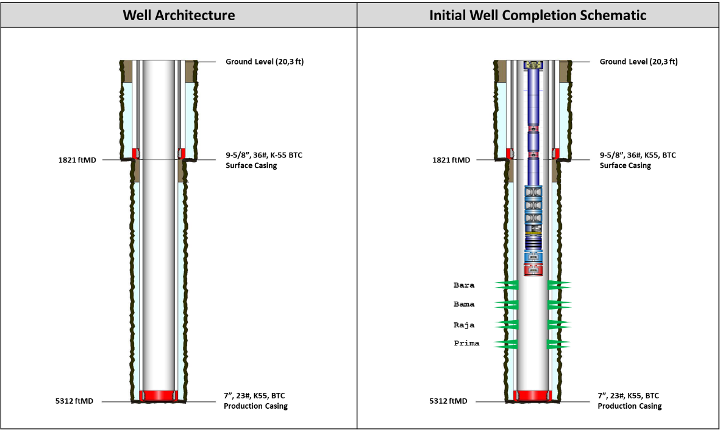
Figure 2.1 Alpha-07 Proposed Well Architecture and Initial Well Completion Schematic

The well architecture figure should show the hole sizes, casing sizes and setting depths, geological intervals, planned TD, and principal reservoir targets. The completion schematic should show the planned 7 in. production casing, perforated reservoir intervals, production tubing, ESP assembly, and associated completion equipment.

  - Subsurface Targets & Data Analysis
- Surface Location & Subsurface Targets
Alpha-07 is planned as a J-type directional development well designed to access the remaining hydrocarbon potential within the Alpha Field. The selected surface location is positioned to accommodate existing surface constraints while providing an effective well path toward the planned subsurface target.

The current well design has a planned total depth of approximately 5,312 ft MD / 4,664 ft TVD, with a horizontal displacement of approximately 2,437 ft toward an azimuth of 135°. The trajectory is designed to penetrate the complete reservoir sequence from Bara through Prima while terminating above the underlying basement.

Table 3.1 Alpha-07 Surface Location and Subsurface Target Coordinates
Parameter | X Coordinate | Y Coordinate | Remarks
Surface Location | 748,934.38 | 110,089.99 | Proposed Alpha-07 Wellpad
Subsurface Target | 749,434.38 | 109,589.99 | Planned Bottom-Hole Target

The surface and subsurface coordinates establish the directional requirement for Alpha-07 and form the basis for the detailed trajectory, anti-collision, and directional drilling design. The current DPM identifies the Alpha-07 design at approximately 5,312 ft MD with a horizontal displacement of approximately 2,437 ft.

- Geological Targets & Formations
Alpha-07 is designed to penetrate a clastic sedimentary sequence consisting predominantly of shale and sandstone intervals. The upper section is characterized by unconsolidated to shale-dominated formations, while the deeper section contains the principal sandstone reservoir intervals targeted for hydrocarbon production.

The primary hydrocarbon objectives are the Bara, Bama, Raja, and Prima reservoir intervals. The key target sand markers are T_Bara1, T_Bama2, T_Raja1, T_Raja3, T_Raja5, and T_Prima1. Available reservoir interpretation indicates that these intervals contain remaining movable hydrocarbons, predominantly oil, with an oil-and-gas indication at T_Bama2.

Table 3.2 Alpha-07 Geological Prognosis and Reservoir Targets
Formation | Predominant Lithology | Prognosed Interval (ft TVD) | Reservoir Objective | Principal Drilling Concern
Surface | Soft Formation / Clay | 0–2,487 | Non-Target | Shallow unconsolidated formation
Arya | Shale | 2,487–3,460 | Non-Target | Sloughing, gumbo, tight hole
Buana | Sandstone / Shale | 3,460–4,042 | Non-Target | Sloughing, gumbo, tight hole
Bara | Sandstone | 4,042–4,238 | Target | Loss circulation, potential tool stop
Bama | Sandstone | 4,238–4,367 | Target | Loss circulation
Raja | Sandstone | 4,367–4,527 | Target | Loss circulation
Prima | Sandstone | 4,527–4,676 | Target | Loss circulation

The geological prognosis indicates a transition from shale-related wellbore instability in the upper intervals to loss-circulation-dominated drilling risk across the deeper sandstone reservoir sequence. The proposed TD is planned to provide sufficient penetration through the Prima interval without extending unnecessarily into the underlying basement.

- Offset Well Data Analysis
Available offset well information provides the primary subsurface calibration basis for Alpha-07. Historical wells in the surrounding area have penetrated equivalent geological intervals and provide information on formation depths, reservoir pressure, drilling hazards, fluid characteristics, and formation evaluation response.

Offset performance indicates that the principal subsurface challenges are associated with shale instability in the upper interval and loss circulation within the deeper reservoir sequence. Sloughing, gumbo, and tight-hole conditions have been observed as relevant risks, while deeper sandstone intervals require particular attention to loss prevention and wellbore condition prior to logging and casing operations.

Shallow gas potential is considered low based on available offset information. The equivalent upper formation shows relatively low Total Gas readings of approximately 1–3 units, compared with approximately 1–4 units in the underlying interval and 2–8 units in the deeper reservoir sequence. Available resistivity data do not indicate significant shallow gas accumulation, and historical offset drilling records do not indicate significant gas readings or gas bubble events.

This offset information supports the current well construction philosophy while providing the calibration basis for drilling fluid design, casing seat selection, PPFG evaluation, well control design, and operational contingency planning.

Table 3.3 Alpha-07 Offset Well Subsurface Design Basis
Design Aspect | Offset Well Observation | Application to Alpha-07
Stratigraphy | Equivalent upper shale and deeper sandstone sequences penetrated | Used for geological prognosis
Wellbore Stability / SFG | Historical shale instability, sloughing, and wellbore condition from offset wells | Used to support Shear Failure Gradient assessment and minimum mud weight design
Loss Circulation | Potential losses within deeper sandstone intervals | LCM and loss contingency required
Shallow Gas | Low TG and no significant historical gas indication | Supports current well construction concept
Reservoir Pressure | Offset pressure information available | Used for PP prediction
Formation Integrity / FG | Historical formation integrity and loss-circulation behavior from offset wells | Used to support Fracture Gradient assessment and maximum allowable ECD / pressure design
Logging | Triple Combo, RFT and SWC established as evaluation basis | Applied to Alpha-07 formation evaluation
Reservoir Fluids | Predominantly oil with localized gas indication | Incorporated into well control and completion design

- Pore Pressure & Fracture Gradient (PPFG) Prediction
The preliminary pore pressure model for Alpha-07 is established using available formation pressure measurements and Eaton-based pressure prediction. Formation fracture gradient and sand fracture gradient are calibrated against historical drilling information to establish the preliminary operating pressure window.

The maximum estimated pore pressure equivalent is approximately 8.66 ppg. The lowest estimated sand fracture gradient within the applicable field dataset is approximately 10.75 ppg, providing the preliminary upper boundary for the drilling fluid and ECD design envelope.

Accordingly, the preliminary drilling fluid program utilizes a mud weight range of approximately 8.7–9.0 ppg for the surface section and 9.0–9.8 ppg for the production section. The final mud weight shall remain sufficient to maintain wellbore stability and overbalance while avoiding excessive ECD that could approach the formation fracture limit.

Table 3.4 Preliminary Alpha-07 PPFG Design Basis
Parameter | Preliminary Design Basis
Maximum Estimated Pore Pressure | 8.66 ppg EMW
Lowest Estimated Sand Fracture Gradient | ~10.75 ppg EMW
Surface Section Mud Weight | 8.7–9.0 ppg
Production Section Mud Weight | 9.0–9.8 ppg
Pressure Prediction Basis | Formation pressure data + Eaton model
FG/SFG Calibration Basis | Historical drilling data
Final Design Requirement | Maintain adequate overbalance while remaining below formation integrity limit
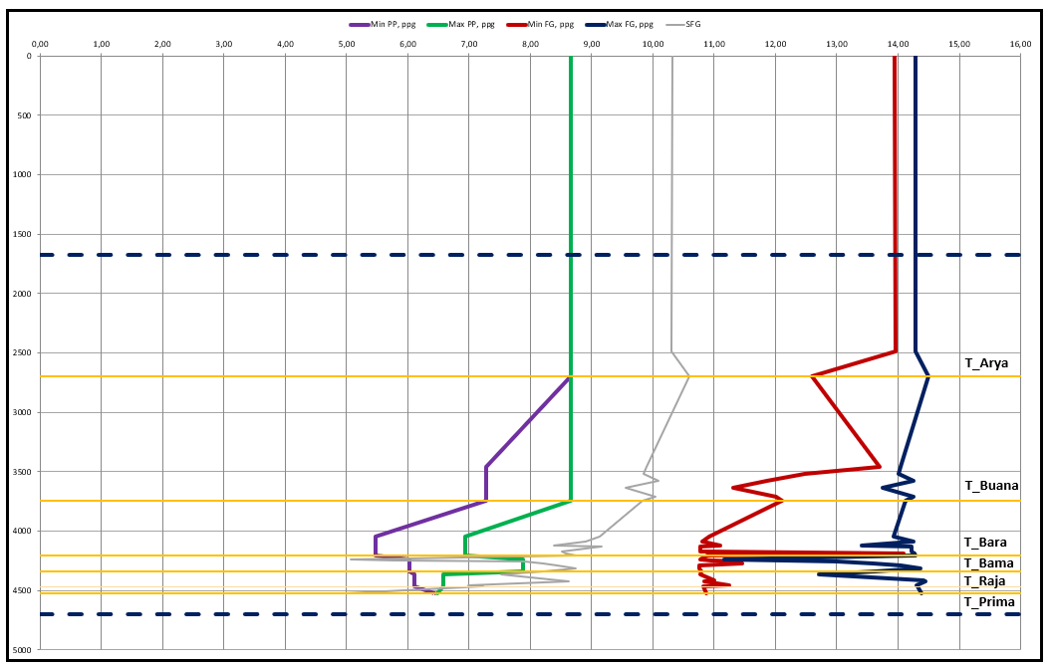
Alpha-07 Predicted Pore Pressure and Fracture Gradient Profile

The PPFG model will subsequently be used as the principal input for casing seat verification, mud weight selection, ECD limits, kick tolerance, cementing hydraulics, and well control calculations.

- Temperature Profile Prediction
The temperature design basis for Alpha-07 is established from available field and offset well information. The applicable field dataset indicates a reservoir temperature of approximately 198°F.

This temperature condition shall be considered in the selection and qualification of downhole equipment, drilling fluid additives, cement slurry systems, logging tools, completion equipment, elastomers, and wellhead components.

Table 3.5 Alpha-07 Temperature Design Basis
Parameter | Design Basis
Expected Reservoir Temperature | ~198°F
Temperature Environment | Non-HPHT
Application | Mud, cement, MWD/LWD, logging and completion equipment design

- Subsurface Hazards
The principal drilling hazards for Alpha-07 are associated with formation instability, gumbo, surface leaking, and loss circulation. In the 12-1/4 in. section, reactive clay, gumbo and surface leaking are identified as the main anticipated problems. As drilling progresses into the 8-1/2 in. production section, the main concerns include reactive clay, sloughing shale, loss circulation during drilling and/or cementing, stuck pipe, differential sticking, logging stop, and casing stop. These conditions may result in deteriorating hole conditions, increased torque and drag, pack-off, restricted pipe movement, difficulties in reaching the planned logging depth, and challenges in running casing to the planned setting depth.

Table 3.6 Alpha-07 Preliminary Subsurface Hazard Summary
Hazard | Expected Interval | Potential Impact | Preliminary Design Response
Reactive Clay / Gumbo | Upper formations / 12-1/4 and 8-1/2 in. section | Bit/BHA balling, poor hole cleaning, reduced ROP | KCl-Polymer system, maintain inhibition and controlled mud properties
Surface Leaking | 12-1/4 in. section / shallow interval | Loss of drilling fluid to shallow formation, poor hole condition | Monitor pit volume and returns, control MW/ECD, prepare loss-control contingency
Sloughing Shale | Shale intervals, particularly production section | Cavings, pack-off, high drag and deterioration of hole condition | Adequate MW, shale inhibition, effective hole cleaning and cavings monitoring
Tight Hole | Shale-dominated intervals | High drag/overpull, difficult tripping, logging/casing restriction | Hole conditioning, monitor torque/drag and verify hole condition before trip
Loss Circulation | Deeper reservoir sandstone intervals | Mud losses, reduced hydrostatic head, cement losses | Maintain MW/ECD within FG window, loss prevention and LCM contingency
Stuck Pipe | 8-1/2 in. production section | NPT, inability to move drillstring, possible fishing requirement | Maintain hole cleaning, monitor torque/drag, minimize static exposure and address tight-hole indications early
Differential Sticking | Permeable reservoir intervals | Stuck pipe / NPT | Maintain appropriate overbalance and minimize stationary contact / static exposure
Shallow Gas / Influx | Shallow interval – low likelihood | Well control event | Maintain overbalance and continuous flow/pit/gas monitoring
Logging Stop | Deeper open hole | Incomplete formation evaluation | Good hole conditioning and circulate clean before logging
Casing Stop | Production section | Unable to reach planned casing setting depth | Condition hole prior to casing run and prepare casing-running contingency

- Data Acquisition / Formation Evaluation Requirement
The Alpha-07 formation evaluation program is designed to confirm reservoir presence, quality, fluid distribution, and pressure characteristics across the principal target intervals. The base formation evaluation program consists of Triple Combo logging, formation pressure measurement (RFT), and Sidewall Core (SWC) acquisition. This evaluation suite is consistently identified for the proposed development wells in the source design data.

Triple Combo logging will provide the principal petrophysical dataset for lithology, porosity, fluid saturation, and reservoir correlation. Formation pressure measurements will be used to evaluate reservoir pressure and fluid contacts and provide additional calibration for the pressure model. Sidewall cores will provide physical formation samples for geological and petrophysical evaluation.

Table 3.7 Alpha-07 Formation Evaluation Requirements
Acquisition | Primary Objective | Application
Triple Combo | Lithology, porosity, resistivity and fluid saturation evaluation | Reservoir characterization and correlation
Formation Pressure Measurement / RFT | Obtain formation pressure data | Reservoir pressure evaluation and PP calibration
Sidewall Core (SWC) | Obtain physical reservoir samples | Lithology and petrophysical validation
MWD Directional Survey | Real-time well position | Trajectory control and target assurance

The formation evaluation program shall be executed after reaching the planned open-hole logging depth and after adequate hole conditioning. Particular attention shall be given to open-hole condition because the identified sloughing, tight-hole, and loss-circulation risks may affect logging tool conveyance and data acquisition.

  - Well Trajectory Design Criteria
- Well Profile
Alpha-07 is designed as a J-type directional well to provide an effective well path from the selected surface location to the planned subsurface target. The J-type profile is selected primarily due to the relatively large horizontal offset between the surface location and the reservoir target. An S-type trajectory would require an additional drop section to reduce inclination before reaching the target, resulting in a longer and more complex well path.

The proposed trajectory consists of a short vertical section, followed by a build section and a tangent section maintained toward the target reservoirs. The well is planned to kick off at approximately 200 ft MD, build inclination at approximately 5°/100 ft, and reach an End of Build (EOB) at approximately 808.2 ft MD. The well will subsequently maintain an inclination of approximately 30.41° along a planned azimuth of 135° toward the subsurface target.

The resulting trajectory provides a horizontal displacement of approximately 2,437 ft and allows the well to penetrate the planned Bara, Bama, Raja, and Prima reservoir intervals before reaching the planned production casing point at approximately 5,312 ft MD / 4,664 ft TVD.

Table 4.1 Alpha-07 Proposed Well Trajectory Design Parameters
Parameter | Design Value
Well Profile | J-Type Directional
Kick-Off Point (KOP) | 200 ft MD
Build-Up Rate (BUR) | 5°/100 ft
End of Build (EOB) | 808.2 ft MD
Start of Drop | N/A
End of Drop | N/A
Hold Inclination | 30.41°
Planned Azimuth | 135°
Horizontal Displacement | 2,437 ft
Surface Casing Point | 1,821 ft MD / 1,654 ft TVD
Production Casing Point | 5,312 ft MD / 4,664 ft TVD
Planned TD | ~5,312 ft MD
Trajectory Sequence | Vertical – Build – Tangent

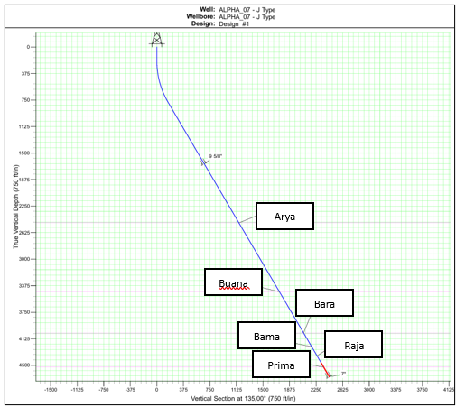
Figure 4.1 Alpha-07 Proposed J-Type Well Trajectory

The selected trajectory is intended to provide a relatively smooth and operationally practical well path while facilitating drilling, logging, casing running, and subsequent completion operations.

- Dogleg Severity (DLS) & Tortuosity Limits
The directional design shall maintain dogleg severity within the operational capability of the drilling assembly and within acceptable limits for subsequent casing, logging, and completion operations. The planned build section applies a nominal BUR of 5°/100 ft from the KOP until the required tangent inclination of approximately 30.41° is achieved.

Once the well enters the tangent section, directional corrections shall be minimized as far as practicable, provided that the well remains within the acceptable trajectory and target tolerance. Unnecessary inclination or azimuth corrections should be avoided to maintain a smooth wellbore profile and minimize local doglegs and wellbore tortuosity. Corrective steering shall only be performed when required to maintain target assurance, trajectory compliance, or anti-collision requirements.

Maintaining a smooth tangent section is particularly important to support subsequent operations, including open-hole logging and production casing running. Actual inclination, azimuth, and DLS trends shall therefore be continuously monitored against the planned trajectory throughout the directional section.

Table 4.2 Alpha-07 Directional Design Criteria
Design Criterion | Design Basis
Planned BUR | 5°/100 ft
Planned Hold Inclination | 30.41°
Planned Azimuth | 135°
Drop Section | Not Required
Tangent Section Steering | Minimize directional corrections while remaining within the acceptable trajectory and target tolerance
Trajectory Tortuosity | Minimize unnecessary local doglegs
Survey Requirement | MWD directional survey
Directional Control | Maintain trajectory within approved directional plan
Primary Operational Consideration | Drilling, logging, casing, and completion accessibility

- Torque & Drag (T&D) Operational Envelope
A torque and drag analysis shall be performed for the proposed Alpha-07 trajectory to verify that drilling, tripping, casing running, and completion operations can be executed within the mechanical and operational limits of the rig, drillstring, casing, and completion equipment. The analysis shall incorporate the final well trajectory, drillstring and casing configurations, expected mud properties, friction factors, and relevant operational load cases.

The analysis shall evaluate pickup, slack-off, rotating weight, surface torque, hookload, axial load, overpull margin, and buckling tendency throughout the planned well depth. Particular attention shall be given to the tangent section, where directional corrections should be minimized to maintain a smooth wellbore profile and reduce additional friction and drag caused by wellbore tortuosity.

Under compressive loading conditions, the analysis shall evaluate the potential onset of sinusoidal and helical buckling of the drillstring. Excessive compression and helical buckling should be avoided during normal operations, as these conditions may increase tubular-to-wellbore contact force, increase torque and drag, and reduce effective weight transfer to the bit.

Predicted torque and drag trends shall establish the baseline for real-time monitoring during drilling operations. Actual pickup, slack-off, rotating weight, and surface torque shall be compared against the predicted operating envelope. Significant deviation from the model shall be investigated as a potential indication of deteriorating hole condition, cuttings accumulation, formation instability, localized restriction, or changes in effective friction.

For casing operations, the analysis shall confirm that sufficient running margin is available to reach the planned setting depths without exceeding allowable equipment and tubular load limits. The casing-running analysis shall also evaluate the effect of increasing drag and compressive loading, particularly where additional push-down force may be required to overcome running resistance.

For completion operations, the predicted running load and drag shall be evaluated to confirm that the 3-1/2 in. tubing and ESP assembly can be deployed to the planned setting depth within the allowable equipment and tubular limits.

Table 4.3 Alpha-07 Torque and Drag Analysis Cases
Analysis Case | Parameters Evaluated | Design Objective
Drilling | Rotating torque, hookload, axial load, buckling tendency | Verify rig/drillstring operating margin and effective WOB transfer
RIH | Slack-off weight, axial compression, buckling | Confirm ability to run string to planned depth without excessive compression
POOH | Pickup weight, drag, overpull | Evaluate drag and available pulling margin
Rotating / Backreaming | Torque, hookload, axial load | Verify operational limits during hole conditioning
Buckling Assessment | Sinusoidal and helical buckling limits | Establish allowable compressive operating envelope and avoid excessive helical buckling
9-5/8 in. Casing Running | Running weight, hookload, drag, compression | Confirm casing can reach planned setting depth
7 in. Casing Running | Running weight, hookload, drag, compression | Confirm production casing can reach planned setting depth
Completion Running | Running load and drag | Confirm 3-1/2 in. tubing and ESP can reach planned setting depth

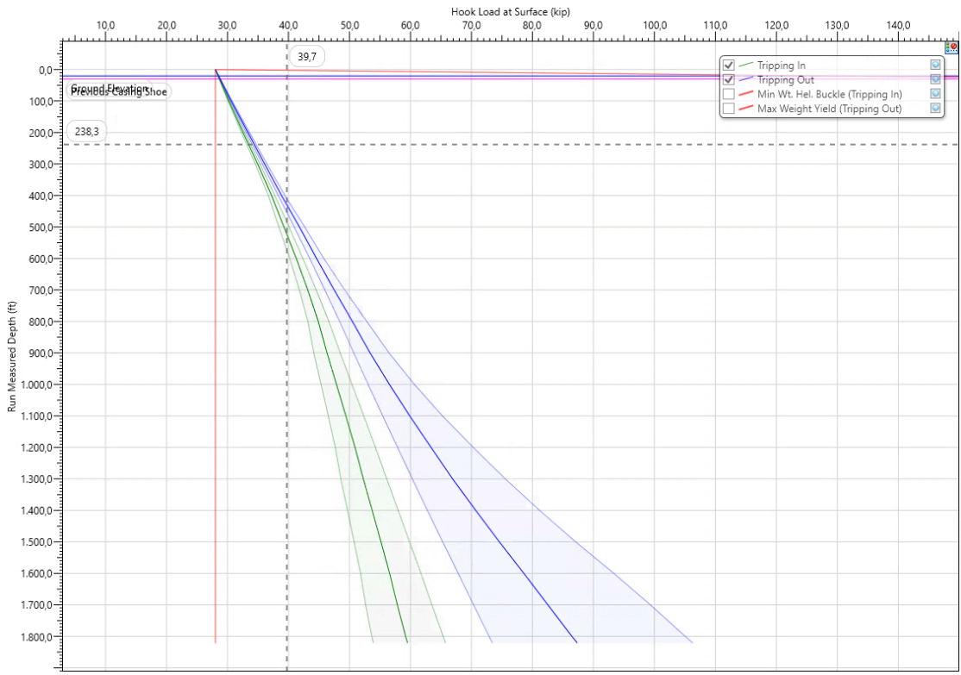
Figure 4.2 Alpha-07 12-1/4 in. Pickup, Slack-Off and Rotating Hookload Simulation
Max P/U hookload at casing point is 101.6 kip (OHFF = 0.5)

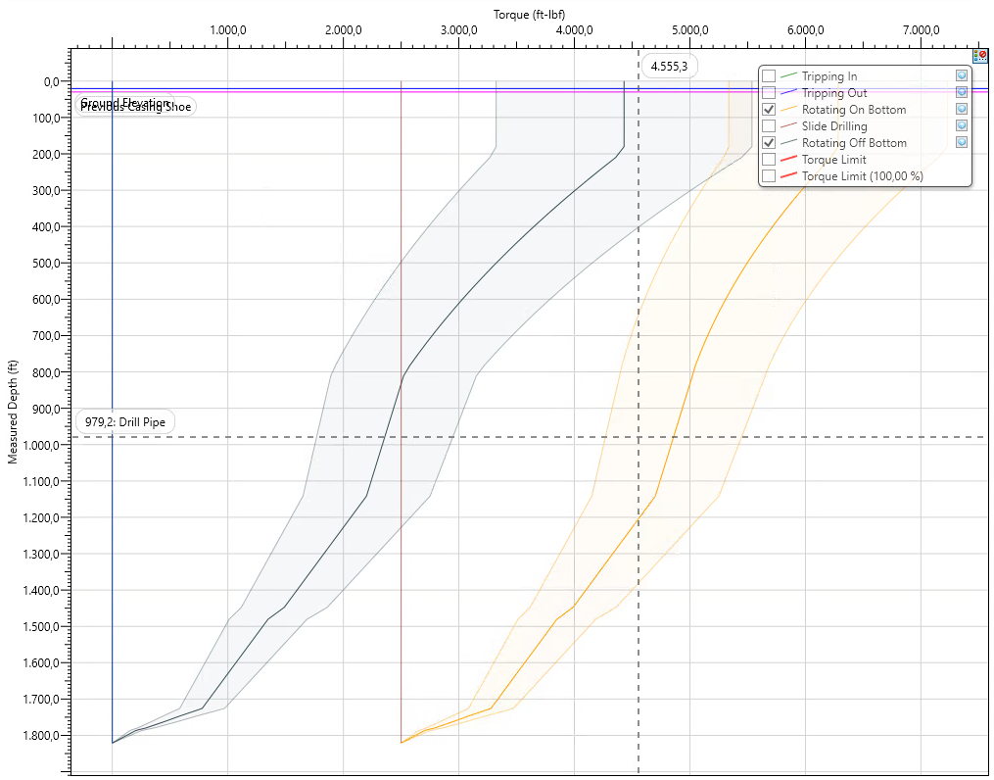
Figure 4.3 Alpha-07 12-1/4 in. Surface Torque Simulation
Max surface torque is 7,228.7 ft.lbf (OHFF = 0.5)

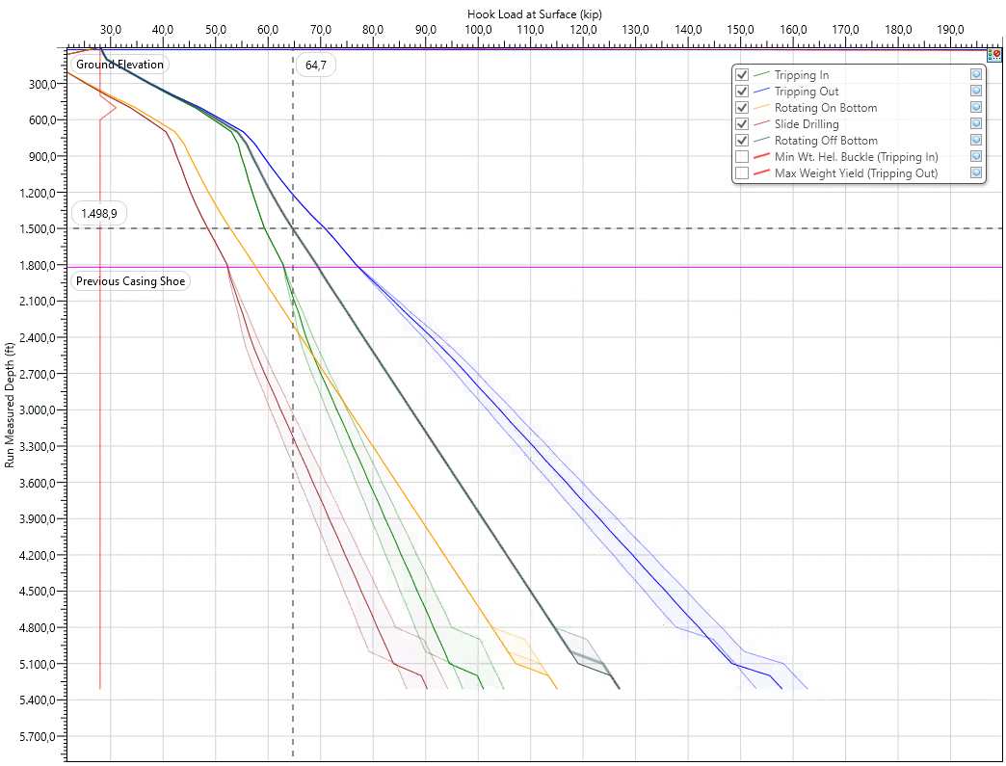
Figure 4.4 Alpha-07 8-1/2 in. Pickup, Slack-Off and Rotating Hookload Simulation
Max P/U hookload at casing point is 162.8 kip (OHFF = 0.5)

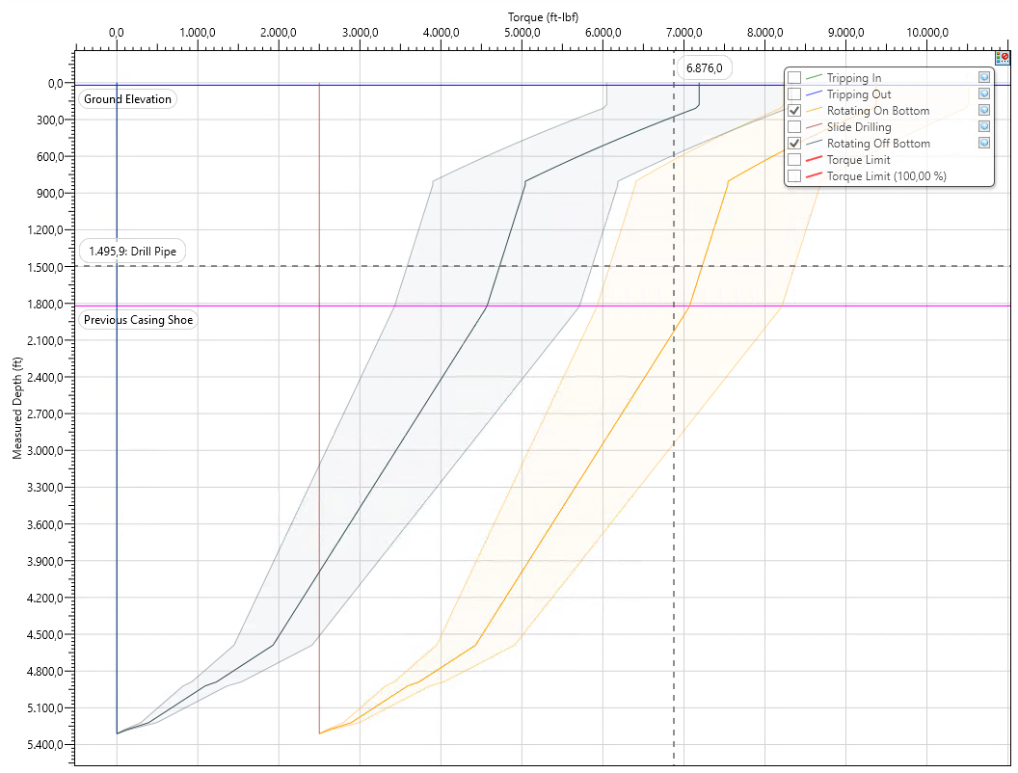
Figure 4.5 Alpha-07 8-1/2 in. Surface Torque Simulation
Max surface torque is 10,515.2 ft.lbf (OHFF = 0.5)

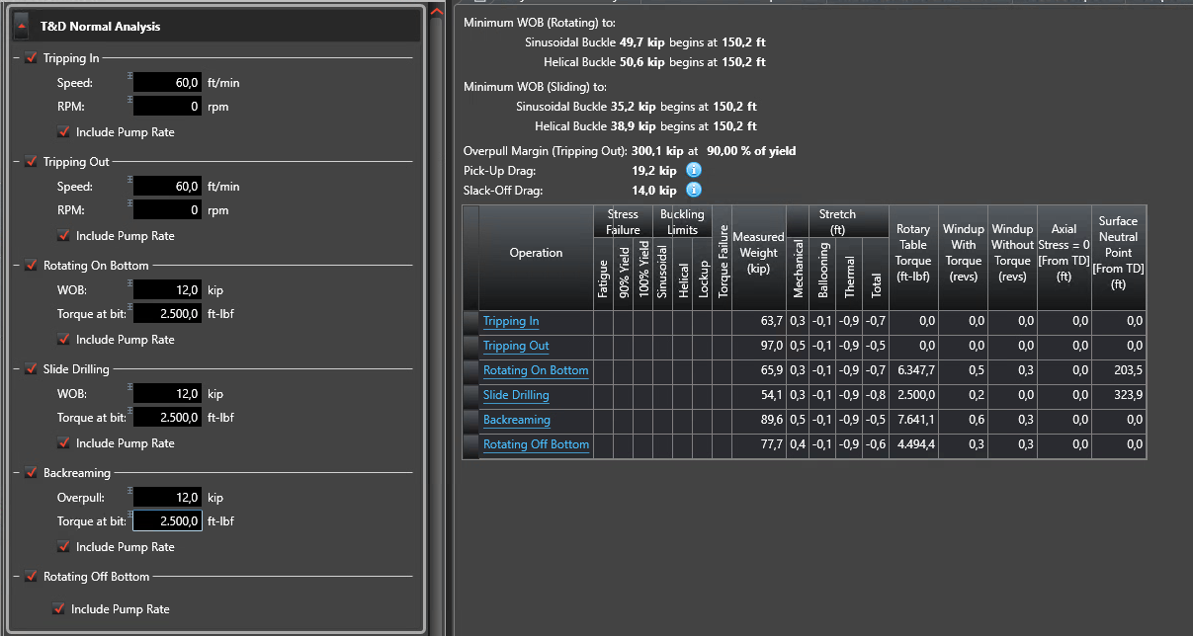
Alpha-07 TnD Summary 12-1/4 in Hole

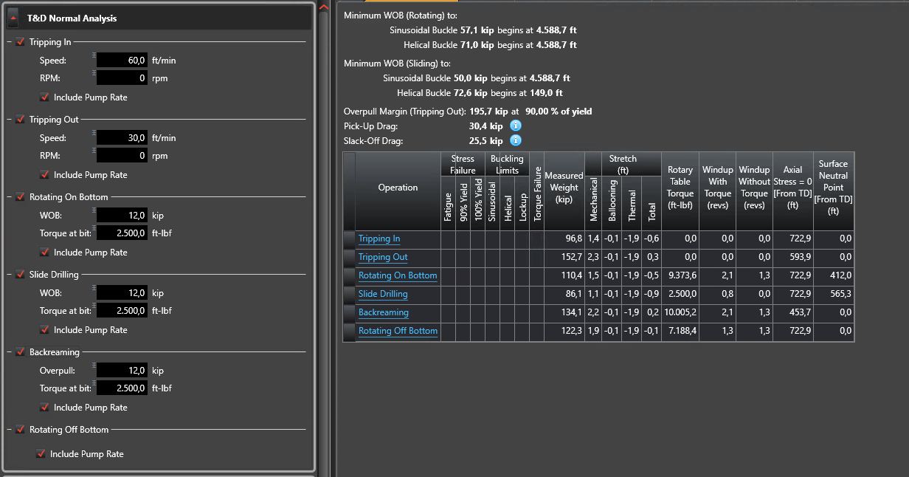
Alpha-07 TnD Summary 8-1/2 in Hole

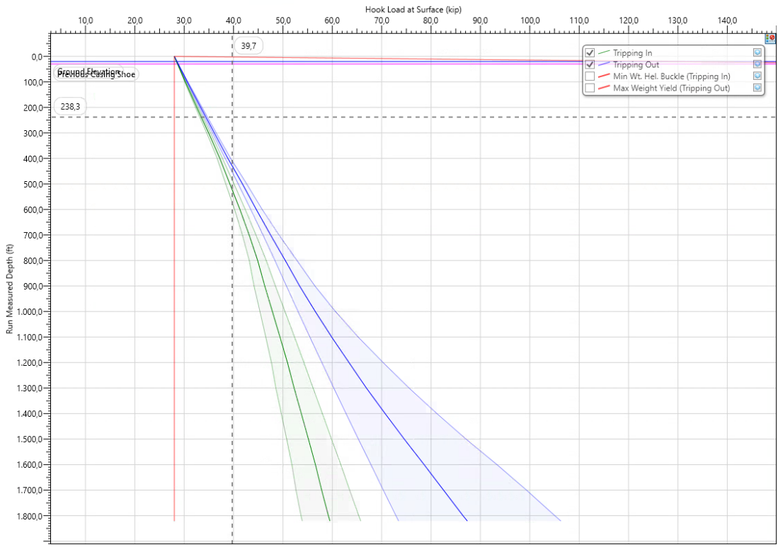
Figure 4.6 Alpha-07 9-5/8 in. Surface Casing Running Analysis
Max P/U hookload at casing point is 106.3 kip (OHFF = 0.5) with centralizer 1 ea per 5 jts casing

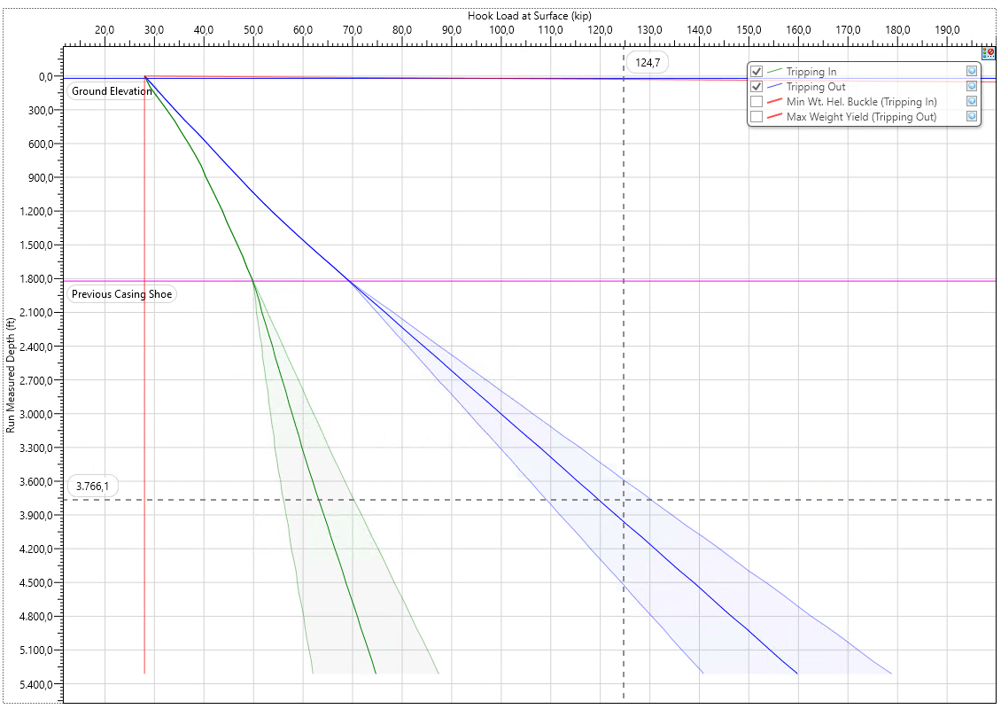
Figure 4.7 Alpha-07 7 in. Production Casing Running Analysis
Max P/U hookload at casing point is 178.8 kip (OHFF = 0.5) with centralizer 1 ea per 5 jts casing inside casing and 1 ea per 3 jts open hole

  - Casing & Tubing Design Criteria
- Casing Seat Selection
The Alpha-07 casing seat selection is based on geological competency, PPFG window, wellbore stability, formation integrity, kick tolerance, and reservoir coverage requirements. The 9-5/8 in. surface casing shoe shall be positioned within a competent shale interval, with the preferred geological setting window identified at approximately 1,550–1,650 ft TVDSS. Landing the casing within competent shale is intended to provide a reliable casing shoe and adequate formation integrity for drilling the subsequent 8-1/2 in. production section.

The current trajectory places the 9-5/8 in. surface casing at approximately 1,821 ft MD / 1,654 ft TVD. The final casing setting depth shall be confirmed against the geological prognosis and actual formation response while drilling to ensure that the shoe is landed in competent shale and remains consistent with the required PPFG and kick tolerance design envelope.

Below the 9-5/8 in. casing shoe, the 8-1/2 in. production section is planned with approximately 9.0–9.8 ppg mud weight. The PPFG assessment indicates that the planned mud-weight envelope remains within the predicted drilling window while considering pore pressure, SFG, and fracture-gradient constraints. Particular attention is required through the deeper shale and reservoir intervals where the operating window becomes narrower due to changes in pore pressure, shear-failure limit, and formation fracture strength.

The 7 in. production casing is planned to be set at approximately 5,312 ft MD / 4,664 ft TVD, providing complete coverage of the Bara, Bama, Raja, and Prima reservoir intervals. The final depth shall provide sufficient interval below the deepest reservoir objective for formation evaluation and safe casing placement.

Table 5.1 – Alpha-07 Casing Seat and PPFG Design Basis
Parameter | 9-5/8 in. Surface Casing | 7 in. Production Casing
Hole Size | 12-1/4 in. | 8-1/2 in.
Casing Size | 9-5/8 in. | 7 in.
Setting Depth, MD | 1,821 ft | 5,312 ft
Setting Depth, TVD | 1,654 ft | 4,664 ft
Planned MW | 8.7–9.0 ppg | 9.0–9.8 ppg
Primary Design Consideration | Upper formation isolation and competent shoe for production-hole drilling | Reservoir isolation and cased-hole completion
Casing Seat Criteria | Land the casing shoe within the identified competent/good shale interval at approximately 1,550–1,650 ft TVDSS | Set below the deepest planned reservoir target to provide complete reservoir coverage and sufficient rat hole
PPFG Verification | Required to confirm adequate formation integrity for drilling the subsequent section | Required to confirm the planned MW remains within the allowable PPFG window
Kick Tolerance Verification | Minimum 10 bbl (1.5 m³) for the subsequent 8-1/2 in. hole, within 0–0.5 ppg kick intensity | N/A as final casing string

Kick tolerance is evaluated at the 9-5/8 in. surface casing shoe, as this shoe represents the pressure containment limit while drilling the subsequent 8-1/2 in. production section. The assessment considers the casing shoe depth, planned mud weight, formation integrity based on LOT, kick intensity, and available annular capacity.

For the 8-1/2 in. production section, the minimum kick tolerance requirement is 10 bbl (approximately 1.5 m³), with a design kick intensity range of 0–0.5 ppg. The calculation uses a 9-5/8 in. casing shoe at 1,821 ft MD / 1,654 ft TVD, a planned production-section TD of 5,312 ft MD / 4,664 ft TVD, a maximum mud weight of 9.8 ppg, and a formation integrity basis of 14.4 ppg from LOT.

The calculated kick tolerance is approximately 33.8 bbl at zero kick intensity. Based on the kick intensity versus kick volume relationship, the allowable kick volume remains above the minimum 10-bbl requirement throughout the specified 0–0.5 ppg kick intensity range. Therefore, the proposed 9-5/8 in. surface casing setting depth provides adequate kick tolerance for drilling the 8-1/2 in. production section.

Table 5.2 – Alpha-07 Kick Tolerance Design Basis
Parameter | Design Basis
Critical Casing Shoe | 9-5/8 in. Surface Casing
Casing Shoe Depth | 1,821 ft MD / 1,654 ft TVD
Subsequent Hole Size | 8-1/2 in.
Section TD | 5,312 ft MD / 4,664 ft TVD
Maximum Planned MW | 9.8 ppg
LOT / Formation Integrity Basis | 14.4 ppg
Minimum Kick Tolerance Requirement | 10 bbl / 1.5 m³
Kick Intensity Design Range | 0–0.5 ppg
Calculated KT @ 0 ppg KI | 33.8 bbl
Design Status | Meets Requirement

- Structural Load Case Design
The Alpha-07 casing strings shall be designed to maintain mechanical integrity under the anticipated burst, collapse, axial, and combined triaxial loading conditions throughout well construction and subsequent well operations. The casing design shall consider credible load cases associated with running the casing, cementing, pressure testing, drilling the subsequent hole section, completion, production, and potential well intervention.

The minimum design factors adopted for the casing design are 1.10 for burst, 1.10 for collapse, 1.25 for axial loading, and 1.25 for triaxial loading.

Table 5.3 – Alpha-07 Casing Structural Load Case Design Criteria
Design Mode | Minimum Design Factor | Applicable Load Cases | Design Consideration
Burst | 1.10 | Gas kick profile, casing pressure test, tubing leak | Internal pressure shall not exceed casing burst resistance
Collapse | 1.10 | Cementing, partial evacuation | External differential pressure shall remain within casing collapse resistance
Axial | 1.25 | Running in hole, casing self-weight, margin overpull | Tensile loading shall remain within allowable casing body and connection capacity
Triaxial | 1.25 | Combined pressure and axial loading | Combined stresses shall remain within allowable casing strength envelope

The applicable load cases are selected according to the function of each casing string. For the 9-5/8 in. surface casing, the primary burst scenarios include the gas kick pressure profile and casing pressure test, while collapse loading considers cementing and partial evacuation conditions. Axial loading shall account for casing running loads and the required margin overpull.

For the 7 in. production casing, the design shall additionally consider the pressure conditions associated with the completed well. The burst assessment therefore includes casing pressure testing and tubing leak scenarios, while collapse and axial evaluations include cementing, partial evacuation, running-in-hole loads, and margin overpull. These load cases are consistent with the casing design cases contained in the technical source.

Table 5.4 – Preliminary Alpha-07 Casing Structural Design Summary
Casing | Burst SF | Collapse SF | Axial SF | Triaxial SF | Preliminary Assessment
9-5/8 in., 36 ppf, K55 | 3.52 | 2.88 | 1.91 | 1.90 | Meets minimum criteria
7 in., 23 ppf, K55 | 2.18 | 1.47 | 1.42 | 1.41 | Meets minimum criteria

The preliminary assessment supports the selection of 9-5/8 in., 36 ppf K55 for the surface casing and 7 in., 23 ppf K55 for the production casing. The selected casing specifications shall be revalidated using the final Alpha-07 trajectory, casing setting depths, PPFG profile, cement program, pressure-test requirements, and completion load cases. Final acceptance shall require all calculated safety factors to remain above the specified minimum design factors.

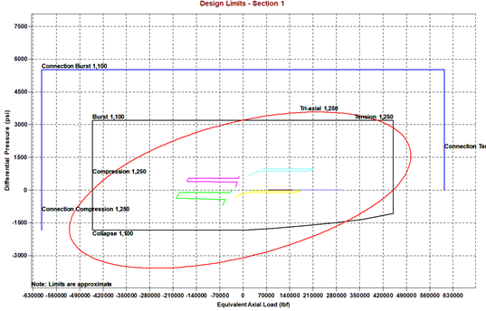
Figure 5.3 Alpha-07 9-5/8 in. Surface Casing Burst, Collapse, Axial and Triaxial Load Analysis

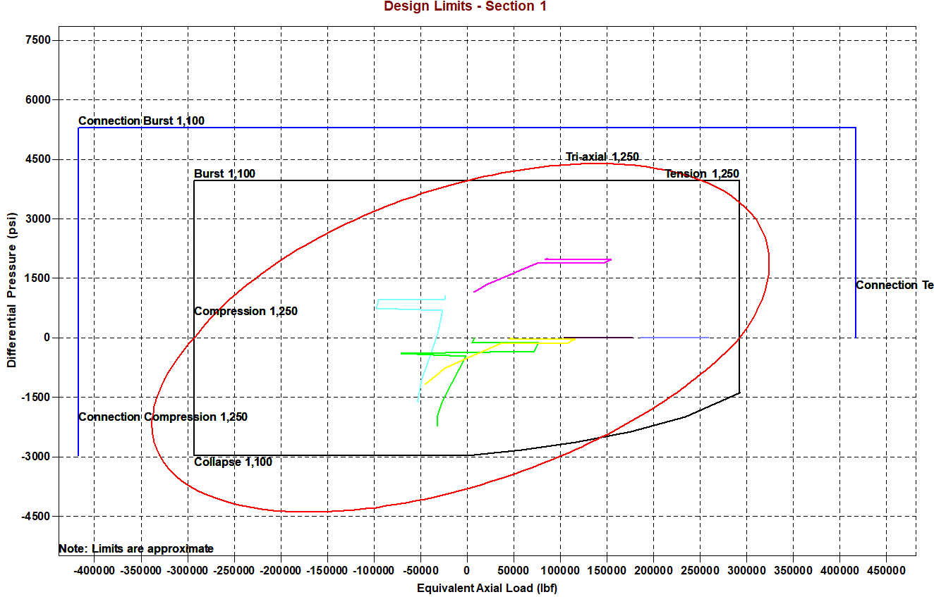
Figure 5.4 Alpha-07 7 in. Surface Casing Burst, Collapse, Axial and Triaxial Load Analysis

- Minimum Material Specifications
The casing and tubing material specifications for Alpha-07 shall provide adequate mechanical integrity throughout drilling, completion, production, and anticipated well intervention operations. Material selection considers the applicable pressure and temperature environment, structural loading, well trajectory, completion configuration, produced-fluid conditions, and compatibility with the planned ESP system.

The base casing design utilizes API K55 steel grade for both casing strings. The 9-5/8 in. surface casing is specified as 36 ppf K55, while the 7 in. production casing is specified as 23 ppf K55. The production tubing is specified as 3-1/2 in., 9.3 ppf, J55 with EUE connection and will serve as the production conduit for the planned ESP completion.

Table 5.5 – Alpha-07 Minimum Casing and Tubing Material Specifications
Parameter | 9-5/8 in. Surface Casing | 7 in. Production Casing | 3-1/2 in. Production Tubing
Nominal OD | 9-5/8 in. | 7 in. | 3-1/2 in.
Nominal Weight | 36 ppf | 23 ppf | 9.3 ppf
API Grade | K55 | K55 | J55
Connection | BTC | BTC | EUE
Minimum Yield Strength | 55,000 psi | 55,000 psi | 55,000 psi
Primary Function | Upper formation isolation and pressure containment | Reservoir isolation and completion conduit | Production conduit and support for ESP completion
Material Selection Basis | Structural load capacity and well-control requirements | Burst, collapse, axial, and triaxial load capacity | Production and completion load requirements
Special Metallurgy | Not required under current design basis | Not required under current design basis | Not required under current design basis

The selected casing and tubing specifications shall satisfy the applicable mechanical load requirements throughout their intended service life. For the casing strings, the structural assessment shall cover burst, collapse, axial, and triaxial loading as defined in Section 5.2. For the production tubing, the design shall consider tubing pressure, external annular pressure, tubing self-weight, ESP assembly load, thermal effects, and applicable completion and production load cases.

- Connection Selection Criteria
The casing and tubing connections for Alpha-07 shall be selected to provide adequate mechanical integrity, pressure containment, running reliability, and compatibility with the selected tubular specifications and planned well operations. Connection selection shall consider the anticipated axial and pressure loads, well trajectory, installation requirements, production conditions, and requirement for long-term well integrity.

The base design utilizes BTC (Buttress Thread and Coupling) connections for both the 9-5/8 in. surface casing and 7 in. production casing, while the 3-1/2 in. production tubing utilizes an EUE (External Upset End) connection. The current well conditions do not identify a requirement for premium casing connections; therefore, API connections are retained as the base design.

Table 5.6 Alpha-07 Casing and Tubing Connection Selection Criteria
Tubular | Selected Connection | Connection Type | Selection Basis
9-5/8 in., 36 ppf, K55 Surface Casing | BTC | API Casing Connection | Adequate mechanical capacity for surface casing installation and subsequent drilling loads
7 in., 23 ppf, K55 Production Casing | BTC | API Casing Connection | Adequate axial and pressure capacity for production casing and cased-hole completion
3-1/2 in., 9.3 ppf, J55 Production Tubing | EUE | API Tubing Connection | Suitable for the planned ESP production string and anticipated production conditions
BTC is selected for both casing strings due to its suitability for the anticipated mechanical loading and directional well profile. Compared with conventional round-thread casing connections, the buttress thread profile provides improved axial load capacity, making it suitable for casing running and subsequent well operations.

For Alpha-07, the moderate maximum inclination of approximately 30.41° and the planned J-type trajectory do not introduce a specific requirement for a premium connection based on the current design basis. Nevertheless, connection capacity shall be verified together with the casing body during the final structural load assessment, particularly for axial and combined loading conditions.

The 3-1/2 in. production tubing will utilize an EUE connection. The external upset configuration provides increased connection cross-sectional area compared with the tubing body end and is commonly applied where sufficient tensile capacity and reliable make-up performance are required.

For Alpha-07, the EUE connection shall be compatible with the planned ESP completion assembly, tubing hanger, check valve, bleeder valve, and other completion components. The connection shall also provide sufficient capacity for the anticipated tubing weight and operational loads during running, production, and future well intervention.

Premium connections are not included in the base design. However, the connection selection shall be reassessed if detailed engineering or updated well conditions identify requirements beyond the capability of the selected API connections, such as:
- higher pressure or temperature conditions;
- significant gas exposure requiring enhanced gas-tight sealing;
- severe combined axial and pressure loading;
- increased trajectory severity or wellbore tortuosity; or
- other well-integrity requirements requiring enhanced connection performance.

Any change from the selected BTC or EUE connections shall therefore be supported by mechanical load verification and compatibility assessment with the associated casing, tubing, wellhead, and completion equipment.

  - Geomechanics & Wellbore Stability Criteria
- Rock Stress Model (Vertical, Max/Min Horizontal Stress)
The geomechanical design for Alpha-07 shall consider the principal in-situ stress components consisting of vertical stress (Sv), maximum horizontal stress (SHmax), and minimum horizontal stress (Shmin). The interpreted stress orientation shall be incorporated into trajectory planning as one of the criteria for minimizing potential wellbore instability.

During well planning, the proposed well azimuth shall be evaluated relative to the interpreted SHmax orientation and historical wellbore stability performance from nearby offset wells. Where practicable, trajectory orientations associated with unfavorable stress conditions or documented wellbore instability shall be avoided.

Historical drilling performance within the Alpha Field provides an important reference for trajectory selection. Alpha-05 experienced sloughing within the upper shale-dominated formation while drilling along an approximately northward trajectory (~N340°). This offset-well behavior shall be considered as an empirical reference when assessing the trajectory orientation for Alpha-07.

Although Alpha-07 is located relatively close to Alpha-05, the proposed trajectory is directed toward the west-southwest, which differs significantly from the problematic trajectory orientation of Alpha-05. The final Alpha-07 azimuth shall therefore be verified against the interpreted SHmax orientation and offset-well stability behavior prior to finalization.

Trajectory selection shall consider the combined requirements of subsurface target accessibility, in-situ stress orientation, offset-well stability performance, surface constraints, and anti-collision requirements.

Table 6.1 – Alpha-07 Rock Stress and Trajectory Orientation Design Criteria
Design Parameter | Design Basis | Application to Alpha-07
Vertical Stress (Sv) | Overburden / formation density data | Input for geomechanical assessment
Maximum Horizontal Stress (SHmax) | Interpreted in-situ stress orientation | Evaluate planned trajectory relative to potential instability
Minimum Horizontal Stress (Shmin) | Formation integrity / fracture behavior | Support fracture and upper pressure-limit assessment
Offset Well Stability | Historical wellbore stability performance | Calibration for trajectory orientation
Problematic Offset Reference | Alpha-05 | Historical sloughing in upper shale interval
Alpha-05 Trajectory | Approximately north / N340° | Reference unfavorable historical trajectory
Alpha-07 Trajectory | West-southwest direction | Different orientation from Alpha-05
Design Criterion | Stress orientation + offset performance | Avoid unfavorable trajectory orientation where practicable

- Wellbore Stability Analysis (Collapse/Breakout Models)
The wellbore stability analysis for Alpha-07 shall evaluate the potential for compressive shear failure, breakout, sloughing, and associated borehole enlargement along the planned trajectory. The assessment shall consider the interaction between pore pressure, in-situ stresses, formation strength, well inclination and azimuth, and the supporting pressure provided by the drilling fluid.

The primary stability concern is expected within the shale-dominated upper formations, where insufficient wellbore support may result in shear failure around the borehole wall. Once the applied mud pressure is insufficient to maintain the required stability condition, the formation may progressively fail and generate cavings or sloughing material, resulting in borehole enlargement and deterioration of hole condition.

The Shear Failure Gradient (SFG) shall be used as the principal reference for defining the minimum mud-weight requirement against compressive wellbore failure. The predicted SFG profile shall be evaluated together with pore pressure and the planned mud-weight profile to maintain sufficient support across stability-sensitive intervals.

Historical offset-well behavior shall also be incorporated into the assessment. The sloughing experienced in Alpha-05 provides an important calibration point for the upper shale interval. Therefore, the stability assessment for Alpha-07 shall consider both the calculated SFG and the observed drilling response from offset wells rather than relying solely on the theoretical model.

In addition, the breakout tendency shall be assessed with respect to the planned well trajectory and interpreted horizontal stress orientation. As established in Section 6.1, the trajectory of Alpha-07 shall avoid, where practicable, orientations associated with unfavorable stress concentration and historical wellbore instability.

Table 6.2 Alpha-07 Wellbore Stability Analysis Criteria
Parameter | Assessment Basis | Design Application
Pore Pressure (PP) | Predicted PP profile | Defines minimum pressure-control requirement
Shear Failure Gradient (SFG) | Geomechanical stability model | Defines minimum MW requirement against shear failure / breakout
SHmax / Shmin | Interpreted horizontal stress orientation | Evaluate stress concentration around the borehole
Formation Strength | Available geological and geomechanical data | Input for collapse / breakout assessment
Well Inclination & Azimuth | Alpha-07 planned trajectory | Evaluate trajectory-dependent stability
Offset Well Calibration | Historical Alpha Field drilling performance | Validate predicted stability behavior
Critical Offset Reference | Alpha-05 sloughing experience | Calibration for upper shale stability
Operational Indicators | Cavings, sloughing, torque, drag, overpull, tight hole | Validate actual stability response while drilling

For BoD purposes, the wellbore stability envelope can be expressed as:
MWoperating​≥MWrequired for stability​
with the SFG used as the reference for the minimum stability-support requirement.
However, mud weight shall not simply be increased whenever instability is observed. The actual drilling response shall first be evaluated because similar symptoms may also result from inadequate hole cleaning, reactive shale behavior, or other drilling-related mechanisms.
The following indicators shall be monitored during execution:
- increasing quantity or size of shale cavings;
- sloughing material at the shale shakers;
- increasing pickup weight and overpull;
- increasing torque and drag;
- repeated tight-hole indications;
- pack-off tendency; and
- progressive borehole enlargement where caliper data are available.
A combination of these indicators, particularly when occurring within the predicted stability-sensitive interval, shall trigger reassessment of the actual mud weight versus SFG, shale inhibition, hole-cleaning performance, and trajectory-related stability exposure.

- Operational Mud Weight Window Determination
The operational mud weight window for Alpha-07 shall be established to provide sufficient wellbore stability and pressure control while maintaining adequate margin below the formation fracture limit. The lower boundary of the operating window is governed by the predicted Pore Pressure (PP) and Shear Failure Gradient (SFG), while the upper boundary is governed by the Fracture Gradient (FG).

For Alpha-07, the preliminary mud weight program is 8.7–9.0 ppg for the 12-1/4 in. section and 9.0–9.8 ppg for the 8-1/2 in. production section. The mud weight profile shall be adjusted progressively with depth based on the applicable PP/SFG requirement and actual wellbore response, rather than applying the maximum planned mud weight throughout the entire section.

From a wellbore stability perspective, the preferred mud weight should provide sufficient support relative to the predicted SFG. However, the applicable mud weight cannot be determined from the SFG at a particular depth independently, as the selected mud weight and resulting ECD act across the entire exposed open-hole interval.

For Alpha-07, increasing the mud weight to fully reach the predicted SFG in the stability-sensitive shale intervals may expose weaker formations elsewhere in the open hole to pressures approaching or exceeding their minimum fracture gradient. Therefore, the operational mud weight is constrained by the weakest exposed formation and may remain below the predicted SFG in some intervals to preserve sufficient fracture margin and minimize the risk of lost circulation.

The selected mud weight shall consequently represent a balance between wellbore stability and formation integrity. Where the operational MW cannot fully satisfy the predicted SFG due to the minimum FG constraint, the remaining shale-instability risk shall be managed through drilling-fluid inhibition, effective hole cleaning, controlled exposure time, and continuous monitoring of cavings, torque and drag, overpull, and hole condition.

Under circulating conditions, particular attention shall be given to ECD, since annular friction increases the effective pressure acting on the exposed formations and further reduces the available margin to the minimum FG.

Table 6.3 – Alpha-07 Operational Mud Weight Window Design Criteria
Parameter | Design Criterion
PP | Maintain sufficient overbalance for pressure control
SFG | Target stability reference; MW should provide adequate support where practicable
Minimum FG in Open Hole | Primary upper constraint for MW/ECD selection across the exposed open-hole interval
MW Selection | Optimize between shale stability requirement and the minimum FG of exposed formations
MW below SFG | May be required where increasing MW toward SFG would compromise fracture margin elsewhere in the open hole
ECD | Maintain sufficient margin below the minimum applicable FG during circulation
Residual Stability Risk | Manage through inhibition, hole cleaning, exposure-time control, and drilling-parameter monitoring

  - Drilling Fluids & Hydraulics Optimization Criteria
- Mud System Selection
A KCl-Polymer Water-Based Mud (WBM) system is selected as the base drilling fluid for Alpha-07 to provide adequate wellbore stability, shale inhibition, pressure control, and hole-cleaning performance throughout the 12-1/4 in. and 8-1/2 in. hole sections. The mud system and planned mud-weight ranges are selected considering the anticipated drilling problems identified for each section.

For the 12-1/4 in. hole section, the planned mud weight is 8.7–9.0 ppg. The primary drilling concerns are reactive clay, gumbo and surface leaking, so the mud system shall provide sufficient inhibition and hole-cleaning capability while maintaining stable drilling conditions through the upper formations.

For the 8-1/2 in. production section, the planned mud weight is 9.0–9.8 ppg. The principal anticipated problems are reactive clay, sloughing, loss circulation during drilling and/or cementing, stuck pipe, differential sticking, logging stop, and casing stop. Accordingly, the mud system shall maintain sufficient wellbore support and cuttings-carrying capacity while preserving adequate fracture margin across the deeper shale and reservoir

Table 7.1 Alpha-07 Drilling Fluid Design Criteria
Parameter | 12-1/4 in. Hole | 8-1/2 in. Production Hole
Mud System | KCl-Polymer WBM | KCl-Polymer WBM
Planned MW | 8.7–9.0 ppg | 9.0–9.8 ppg
Main Formation Behavior | Upper shallow formation and shale interval | Shale and deeper reservoir sandstone intervals
Main Mud Function | Shale inhibition, wellbore stability, and hole cleaning | Wellbore stability, pressure control, hole cleaning, and reservoir-section drilling
Main Drilling Risks | Reactive clay, gumbo and surface leaking | Reactive clay, Sloughing, loss circulation during drilling and/or cementing, stuck pipe, differential sticking, logging stop, and casing stop
MW Selection Basis | PP, wellbore stability, and applicable FG | PP, SFG, minimum applicable FG, and actual hole response

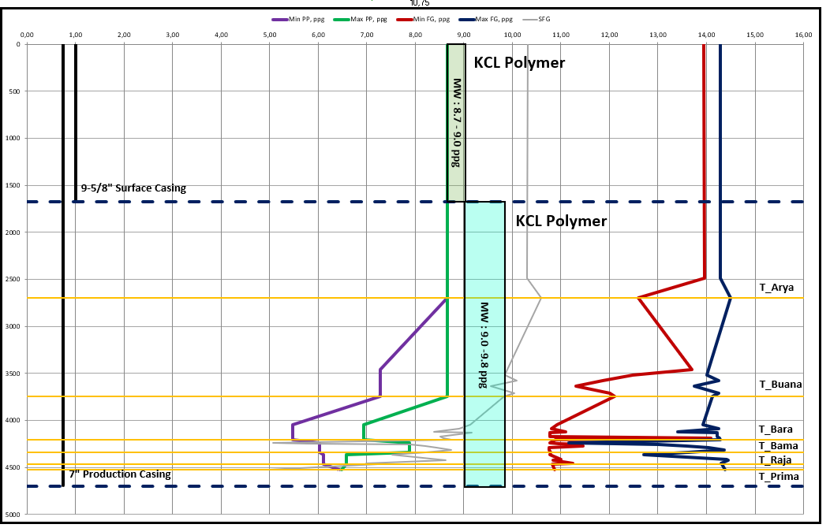
Figure 7.1 Alpha-07 Drilling Fluid and Mud Weight Program

- Minimum Rheological Property Requirements
The Alpha-07 drilling fluid rheology shall be maintained to provide adequate cuttings carrying capacity, shale inhibition, and wellbore stability while minimizing excessive annular pressure losses and ECD. The required rheological properties vary between the 12-1/4 in. and 8-1/2 in. hole sections according to the expected formation behavior, hole geometry, and hydraulic requirements.

For the 12-1/4 in. hole section, the KCl-Polymer WBM shall be maintained within a mud-weight range of 8.7–9.0 ppg, with Plastic Viscosity maintained As Low As Practicable (ALAP), Yield Point of 16–22 lb/100 ft², and a minimum KCl concentration of 5%. The objective is to provide sufficient shale inhibition and cuttings transport while limiting unnecessary annular friction across the relatively large hole section.

For the 8-1/2 in. production section, the KCl-Polymer system shall be maintained within 9.0–9.8 ppg, with PV maintained ALAP, YP increased to approximately 26–30 lb/100 ft², and KCl concentration maintained at a minimum of 5%. The higher YP requirement is intended to provide improved carrying capacity across the longer directional and reservoir interval while maintaining acceptable hydraulic performance.

Rheological properties shall be monitored and adjusted according to actual hole conditions, cuttings return, torque and drag trends, and hydraulic response. Any increase in YP or viscosity to improve hole cleaning shall be evaluated against the resulting ECD to ensure that the available fracture margin is maintained.

Table 7.2 Alpha-07 Minimum Rheological Property Requirements
Property | 12-1/4 in. Hole | 8-1/2 in. Production Hole
Mud System | KCl-Polymer WBM | KCl-Polymer WBM
MW Range | 8.7–9.0 ppg | 9.0–9.8 ppg
PV | ALAP | ALAP
YP | 16–22 lb/100 ft² | 26–30 lb/100 ft²
KCl Concentration | 5% | 5%
LSRYP | Not Specified | 7 – 10
Max API Filtrate | 10 | 5
Max MBT | 12.5 | 12.5
Shaker Screen | 80–140 | 140–200

- Equivalent Circulating Density (ECD) Limits
The Alpha-07 ECD shall be maintained within the operational pressure window established from the PPFG and wellbore stability assessment. The maximum allowable ECD shall not be determined solely from the fracture gradient at the current bit depth, but shall consider the minimum applicable fracture gradient across the entire exposed open-hole interval.
This criterion is particularly important because the static mud weight selected for Alpha-07 acts across the entire open-hole section, while annular friction during circulation further increases the effective bottom-hole pressure. Consequently, increasing flow rate or mud rheology to improve hole cleaning may reduce the available fracture margin at a weaker formation located above the bit.
The hydraulic simulation shall therefore evaluate ECD at both the bit and casing shoe, together with any identified weak formation interval.
The design criterion is:
ECDoperating​<FGlimiting​​
with adequate operational margin maintained for expected variations in mud properties, cuttings loading, flow rate, and hole condition.

Table 7.3 Alpha-07 ECD Design Criteria
Parameter | Design Criterion
Static MW | Within approved Alpha-07 MW window
ECD at Bit | Below applicable FG
ECD at Shoe / Weak Interval | Below applicable formation integrity limit
SPP | Within allowable surface equipment and BHA pressure limits
Operating Flow Rate | Within both ECD and SPP operating envelope
Annular Pressure Loss | Considered in ECD calculation
System Pressure Loss | Considered in SPP calculation
Hydraulic Monitoring | SPP, ECD, flow rate, MW and rheology

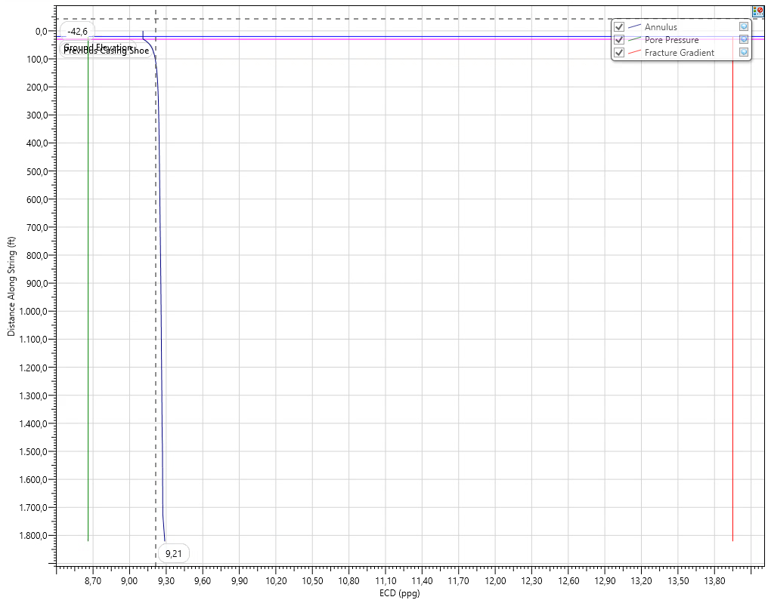
Figure 7.2 Alpha-07 ECD versus Flow Rate 12-1/4” Hole
Max ECD is 9.29 ppg with Flow Rate 900 gpm

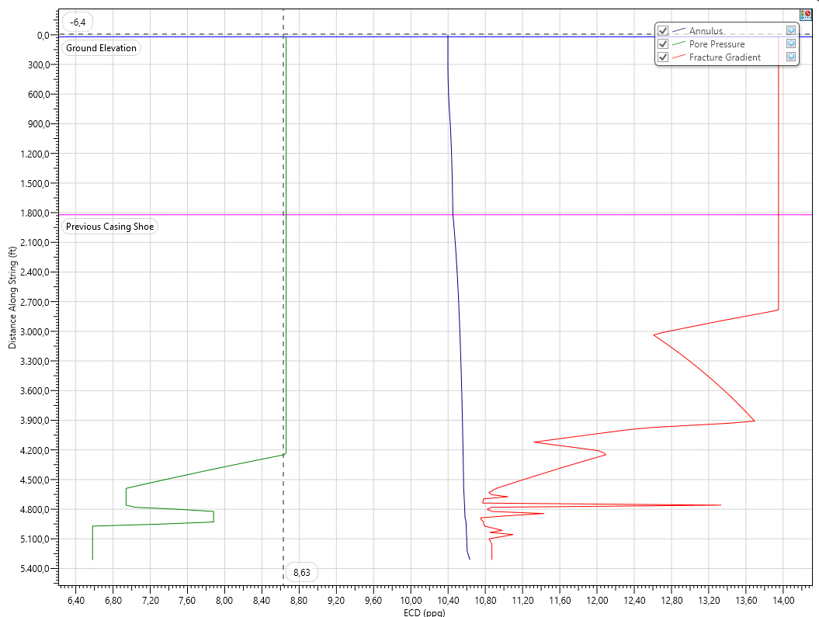
Figure 7.3 Alpha-07 ECD versus Flow Rate 8-1/2” Hole
Max ECD is 10.64 ppg with Flow Rate 600 gpm (Still below with Min FG at 10.75 ppg)

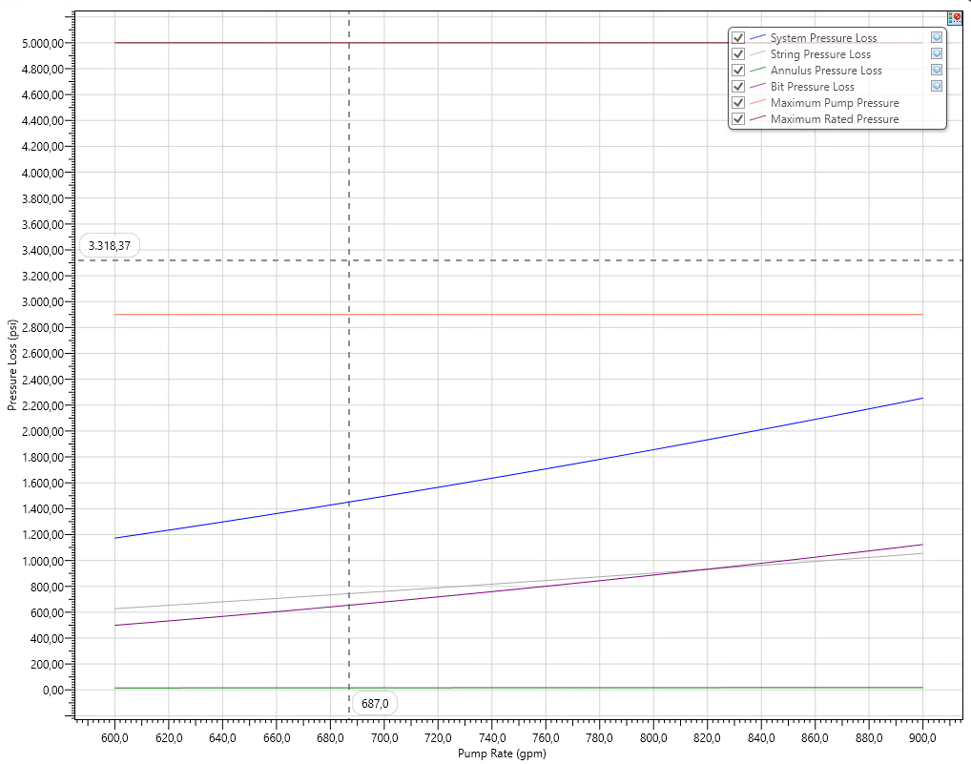
Figure 7.4 Alpha-07 Standpipe Pressure versus Flow Rate 12-1/4” Hole
Max SPP is 2254.89 psi with Flow Rate 900 gpm (Still below with Max PRV 6” Liner at 2900 psi)

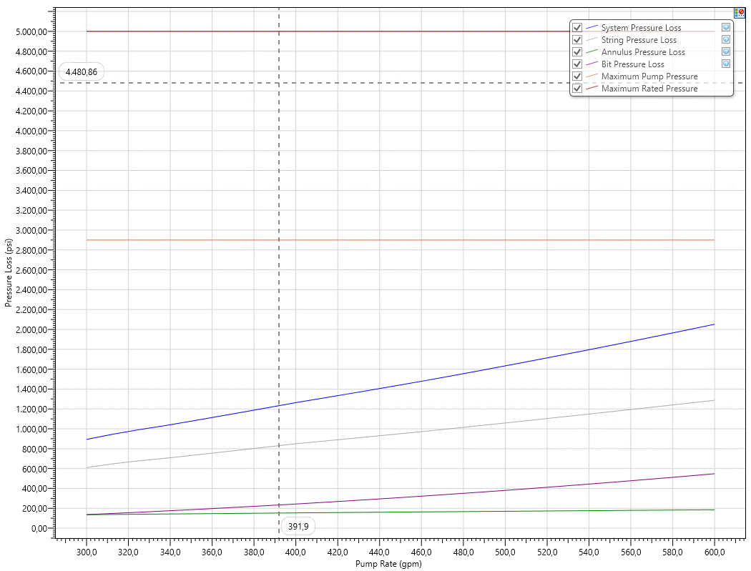
Figure 7.5 Alpha-07 Standpipe Pressure versus Flow Rate 8-1/2” Hole
Max SPP is 2052.43 psi with Flow Rate 600 gpm (Still below with Max PRV 6” Liner at 2900 psi)

- Hole Cleaning Requirements
Hole cleaning for Alpha-07 shall be designed considering the 12-1/4 in. and 8-1/2 in. hole geometry, J-type trajectory, maximum inclination of approximately 30.41°, mud rheology, ROP, RPM, flow rate, and cuttings characteristics.

The 12-1/4 in. section includes the build section from the planned KOP at approximately 200 ft MD, reaching approximately 30.41° inclination, followed by a tangent interval toward the surface casing point. The 8-1/2 in. section subsequently continues predominantly as a tangent section toward TD. Therefore, cuttings transport shall be evaluated not only for the vertical portion but also for the inclined section where cuttings-bed development may become more significant.

The minimum flow rate shall be established through cuttings-transport simulation as a function of depth and ROP. The planned operating flow rate shall remain above the calculated minimum requirement while simultaneously satisfying the ECD and SPP limitations.

The hydraulic operating philosophy shall therefore follow:
FROperating​>FRMinimum Hole Cleaning​​

subject to:
ECD<FGlimiting​​

If increasing ROP causes the required cuttings-transport flow rate to exceed the available hydraulic envelope, the drilling rate shall be controlled rather than increasing flow rate beyond the ECD or SPP limit.

Table 7.4 Alpha-07 Hole Cleaning Design Criteria
Parameter | 12-1/4 in. Hole | 8-1/2 in. Hole
Hole Size | 12-1/4 in. | 8-1/2 in.
Trajectory | Build + Tangent | Tangent
Maximum Inclination | ~30.41° | ~30.41°
MW | 8.7–9.0 ppg | 9.0–9.8 ppg
Cutting’s diameter | 0.190 | 0.250
Cutting’s density | 1.9 | 2.2
Design ROP | 100 | 100
RPM | 40 | 90
Minimum Flow Rate | 520.7 gpm | 464. 3 gpm
Operating Flow Rate | > Minimum FR | > Minimum FR
Maximum Flow Rate | Limited by ECD / SPP / BHA | Limited by ECD / SPP / BHA

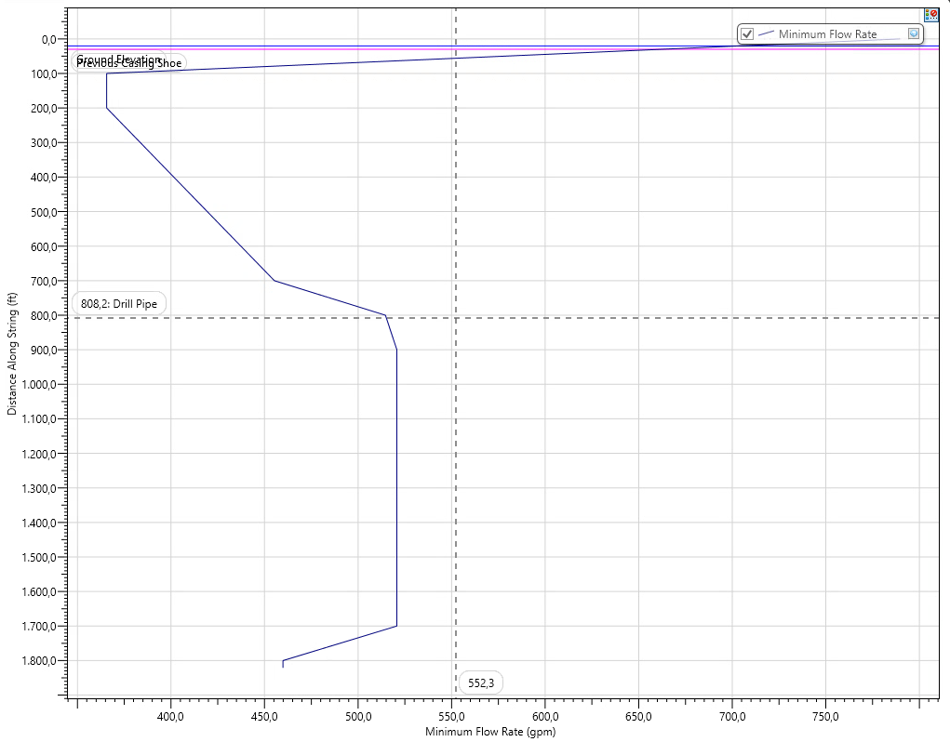
Figure 7.6 Alpha-07 Minimum Flow Rate versus Depth 12-1/4 in. Hole
Minimum flow rate to clean out around 520.7 gpm with MW 9.0 ppg

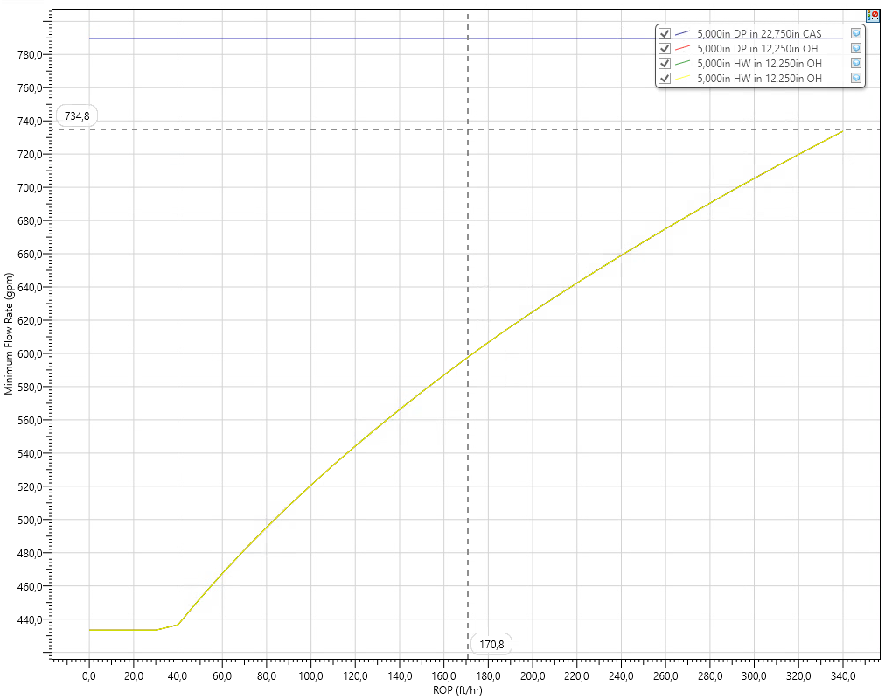
Figure 7.7 Alpha-07 Minimum Flow Rate versus ROP 12-1/4 in. Hole
Minimum flow rate to clean out around 520.7 gpm with ROP 100 fph

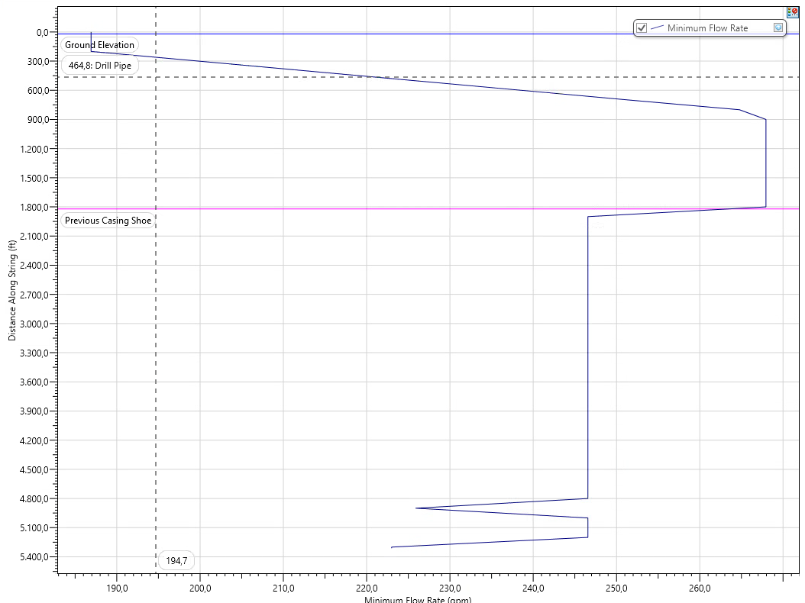
Figure 7.8 Alpha-07 Minimum Flow Rate versus Depth 8-1/2 in. Hole
Minimum flow rate to clean out around 267.9 gpm with MW 9.8 ppg

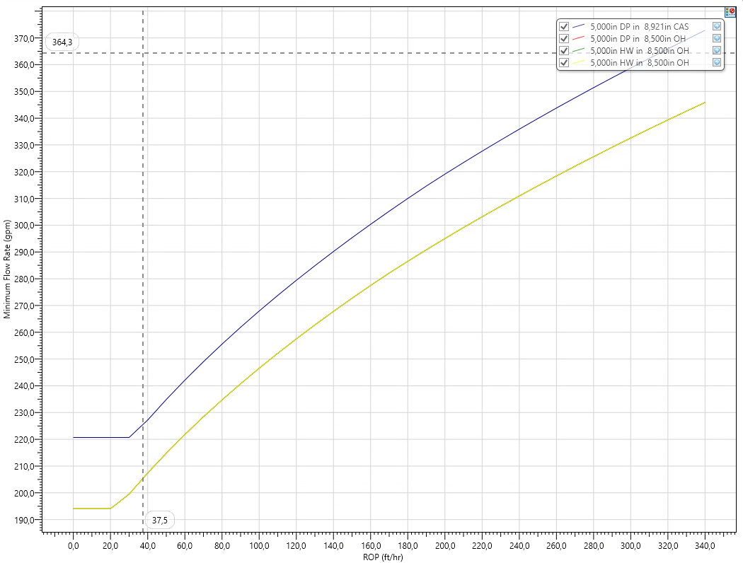
Figure 7.9 Alpha-07 Minimum Flow Rate versus ROP 8-1/2 in. Hole
Minimum flow rate to clean out around 267.9 gpm with ROP 100 fph

e. Bit Hydraulics Optimization
Bit hydraulics for Alpha-07 shall be optimized to provide adequate bottom-hole cleaning and hydraulic energy at the bit while maintaining standpipe pressure and ECD within the allowable operating envelope. The assessment shall consider the selected bit TFA, operating flow rate, bit pressure loss, nozzle velocity, and Hydraulic Horsepower per Square Inch (HSI).

The selected hydraulic configuration shall provide sufficient jet energy to clean the bit face and remove generated cuttings without imposing excessive pressure losses on the circulating system. HSI shall therefore be evaluated together with bit pressure loss and nozzle velocity rather than treated as an independent optimization target.

Final values shall be established from the Alpha-07 hydraulic simulation using the selected BHA, bit nozzle configuration, mud properties, and operating flow rate.

Table 7.5 Alpha-07 Bit Hydraulics Design Criteria
Parameter | 12-1/4 in. Hole | 8-1/2 in. Hole | Design Check
Operational Flow Rate | 900 gpm | 600 gpm | Above minimum hole-cleaning requirement
Bit TFA | 0.77 in2 | 0.77 in2 | Per selected bit/nozzle design
HSI | 5 hp/in2 | 3.4 hp/in2 | Adequate bit cleaning
Bit Nozzle Velocity | 374 ft/s | 250 ft/s | Adequate jet velocity
Bit Pressure Loss | 1123.35 psi | 547.89 psi | Within hydraulic allocation
SPP | 2254.89 psi | 2052.43 psi | Below system pressure limit
Pump Power | 1183.82 hp | 718.35 hp | Within pump capability
Bit Hydraulic Power | 589.76 hp | 191.76 hp | Adequate hydraulic energy
Power at Bit | 49.82% | 26.69% | Within optimized hydraulic distribution
Annular Pressure Loss | 18.14 psi | 185.29 psi | ECD impact acceptable
ECD at Shoe | 9.11 ppg | 10.45 ppg | Below applicable FG
ECD at Bit | 9.29 ppg | 10.64 ppg | Below applicable FG

  - Cementing & Zonal Isolation Criteria
- Cementing Objectives
The Alpha-07 cementing and zonal isolation design shall support the two-string well architecture and provide reliable structural support, hydraulic isolation, and long-term well integrity for the planned cased-hole ESP completion. The 9-5/8 in. surface casing is planned at approximately 1,821 ft MD, while the 7 in. production casing is planned to approximately 5,312 ft MD, covering the principal reservoir intervals. The base cementing philosophy uses Class G cement with a dual-slurry system, consisting of a minimum 12.5 ppg lead slurry and 15.8 ppg tail slurry, preceded by an 11.0 ppg scavenger/spacer.

The primary cementing objective is to establish a continuous and competent cement sheath behind each casing string to provide structural support, hydraulic isolation, and long-term well integrity. The cementing design shall also maintain sufficient formation-integrity margin during placement and minimize the potential for losses, poor displacement, channeling, and inadequate cement coverage.

For the 9-5/8 in. surface casing, cementing shall isolate the shallow formation interval, protect groundwater-bearing zones where applicable, provide structural support to the wellhead and casing string, and establish a competent shoe for subsequent drilling of the production section. The tail slurry shall provide higher-strength cement around the casing shoe, with a preliminary minimum tail coverage of 200 ft above the casing point.

For the 7 in. production casing, the primary objective is effective hydraulic isolation across the reservoir-bearing interval while providing a competent cement sheath for subsequent selective perforation and ESP completion. The tail slurry shall extend sufficiently above the upper critical reservoir interval, with the current field design basis specifying a minimum of approximately 500 ft above the upper target sandstone interval.

Historical offset experience is particularly relevant to Alpha-07 because several offset wells recorded incomplete or absent cement return during primary cementing. Other wells achieved surface return after applying substantial excess cement volumes. Therefore, achieving the planned cement coverage shall be supported by adequate excess-volume design, hole-volume verification, displacement optimization, and contingency planning rather than relying only on theoretical gauge-hole volume.

Table 8.1 Alpha-07 Cementing and Zonal Isolation Objectives
Casing String | Cementing Objective | Preliminary Tail Coverage | Key Risk / Consideration
9-5/8 in. Surface Casing | Shallow-zone isolation, structural support, competent shoe for production-hole drilling | Minimum ~200 ft above casing point | Hole enlargement, poor displacement, incomplete cement return
7 in. Production Casing | Reservoir zonal isolation, casing support, long-term integrity and cased-hole completion support | Minimum ~500 ft above upper critical reservoir interval | Loss circulation, poor cement return, inadequate zonal isolation
Future Abandonment | Provide annular barrier contribution to final well barrier system | As required by abandonment design | Long-term barrier integrity

The cement sheath shall also provide a competent annular barrier that can contribute to future suspension and abandonment requirements, although the final abandonment barrier design shall be established separately at the appropriate well-life stage.

- Cement Slurry Property Limits
A Class G dual-slurry cement system shall be used as the base design. The preliminary density requirement is minimum 12.5 ppg for the lead slurry and 15.8 ppg for the tail slurry.

The lead slurry is intended primarily to provide sufficient annular fill and zonal coverage while reducing the hydrostatic loading compared with the higher-density tail slurry. The tail slurry shall provide higher mechanical strength around the shoe and critical isolation interval.

The final slurry design shall be laboratory tested using the Alpha-07-specific BHCT, BHST, mix water, and expected job duration. The thickening time shall exceed the predicted placement time with adequate operational safety margin. The slurry shall also develop sufficient compressive strength before subsequent pressure testing, drilling out, or completion operations.

Reference cement laboratory data illustrate the expected design philosophy. For a 9-5/8 in. casing application, a 12.5 ppg lead slurry achieved 0% free water, a 70-BC thickening time of approximately 3 hr 34 min, and approximately 500 psi compressive strength after 16 hr 18 min under the applicable laboratory conditions. For a deeper 7 in. production-casing application, the 12.5 ppg lead slurry achieved a 70-BC thickening time of approximately 4 hr 25 min, while the 15.8 ppg tail slurry achieved approximately 4 hr 30 min; both were tested with zero free water.

These laboratory values shall be treated as reference performance, not final Alpha-07 acceptance values.

Table 8.2 Alpha-07 Cement Slurry Property Design Criteria 12-1/4 in. Hole
Parameter | Lead Slurry | Tail Slurry
Cement Type | Class G | Class G
Density | Minimum 12.5 ppg | 15.8 ppg
Primary Function | Annular fill and zonal coverage with reduced hydrostatic loading | Higher-strength cement around shoe and critical isolation interval
Excess | 150% excess over theo | 150% excess over theo
Free Water | Target 0% | Target 0%
Thickening Time | Thickening time: < 4 hrs (70BC) | Thickening time: < 4 hrs (70BC)
Compressive Strength | Min. 600 psi and ≤ 17 hrs | Min. 1500 psi and ≤ 7 hrs
24 hr crush | ≥ 600 psi | ≥ 1750 psi
Fluid Loss | < 300 | < 100
BHCT / BHST | 122 deg F | 122 deg F
Mud–Spacer–Cement Compatibility | Required | Required

Table 8.2 Alpha-07 Cement Slurry Property Design Criteria 8-1/2 in. Hole
Parameter | Lead Slurry | Tail Slurry
Cement Type | Class G | Class G
Density | Minimum 12.5 ppg | 15.8 ppg
Primary Function | Annular fill and zonal coverage with reduced hydrostatic loading | Higher-strength cement around shoe and critical isolation interval
Excess | 200% excess over theo | 40% excess over theo
Free Water | Target 0% | Target 0%
Thickening Time | Thickening time: < 6 hrs (70BC) | Thickening time: < 4 hrs (70BC)
Compressive Strength by UCA and in hrs | Min. 600 psi and ≤ 20 hrs | Min. 1000 psi and ≤ 8 hrs
24 hr crush | ≥ 600 psi | ≥ 2000 psi
Fluid Loss | < 150 | < 100
BHCT / BHST | 198 deg F | 198 deg F
Mud–Spacer–Cement Compatibility | Required | Required

- Placement Strategy & Displacement Efficiency Criteria
The Alpha-07 cement placement strategy shall be designed to maximize mud removal, displacement efficiency, casing centralization, and circumferential cement coverage, while maintaining the cementing ECD below the applicable formation integrity limit. Particular attention shall be given to pre-job hole conditioning, spacer effectiveness, casing movement, centralizer placement, displacement rate, and final cement placement across the critical isolation intervals.

Prior to cementing, the well shall be adequately conditioned until stable mud properties and acceptable returns are achieved. As a preliminary design criterion, circulation shall be performed for a minimum of approximately two hole volumes after the casing reaches setting depth. A compatible 11.0 ppg scavenger/spacer shall be pumped ahead of the cement system to provide effective separation between the drilling fluid and cement and improve mud removal. The reference cementing program uses approximately 40 bbl of 11.0 ppg scavenger at 4 bpm with approximately 10 minutes contact time.

Where operationally feasible, the casing shall be reciprocated during conditioning and cement placement to improve mud displacement and reduce the likelihood of preferential cement channels. A preliminary reciprocation range of approximately 1–2 ft may be applied from mud conditioning through pumping of the tail slurry, subject to actual casing-running condition and equipment capability.

Casing centralization shall be designed to provide adequate stand-off across the critical cementing intervals. As a preliminary placement philosophy, centralizers shall be installed approximately one centralizer every five joints (1:5) within the previously cased-hole interval and one centralizer every three joints (1:3) in open hole. A minimum design standoff of approximately 67% shall be targeted across critical isolation intervals, with higher standoff preferred where practical. Final centralizer quantity and spacing shall be confirmed through standoff simulation using the final Alpha-07 trajectory, casing configuration, and actual hole geometry.

The cementing system shall use the planned 12.5 ppg lead slurry and 15.8 ppg tail slurry. Following placement of the cement slurry and release of the top plug, displacement for the production-casing cement job shall use 8.4 ppg brine as the preliminary displacement fluid. The reference 7 in. cementing program applies 8.4 ppg brine during displacement and reduces the pumping rate toward the end of displacement to provide controlled plug landing and minimize excessive final pressure.

The displacement rate shall be sufficient to improve mud removal and cement placement without causing excessive ECD or exceeding the applicable fracture limit. Hydraulic simulation shall therefore verify the complete pumping sequence, including scavenger, lead slurry, tail slurry, displacement fluid, surface pressure, and ECD at the casing shoe and other identified weak formations. Cementing hydrostatic and circulating pressures shall remain within the available PPFG operating window throughout placement.

Adequate shoe-track volume shall be maintained to minimize cement contamination around the casing shoe and ensure sufficient competent cement below the float collar. A minimum shoe-track requirement equivalent to approximately 1.5% of the total displacement volume shall be maintained as the preliminary design criterion.

The final cement volume shall incorporate appropriate open-hole excess based on actual hole condition, available caliper information, and historical Alpha Field cement-return performance. Where significant loss circulation is observed before cementing, the placement design shall be reassessed and may incorporate lightweight cement and fiber, together with reduced hydraulic loading and top-job contingency if required. The field design basis specifically identifies lightweight cement and fiber as the contingency for loss circulation in the production section.

The top plug shall be bumped at approximately 500 psi above the calculated final displacement pressure, provided this remains within the casing, float equipment, and cementing-system pressure limits.

  - Bottom Hole Assembly (BHA) & Bit Selection Criteria
- Fundamental BHA Design per Section
For the 12-1/4 in. hole section, Alpha-07 will utilize a mud-motor directional BHA designed to drill the build-and-tangent section from the planned KOP at approximately 200 ft MD to the 9-5/8 in. surface casing point at approximately 1,821 ft MD. The BHA shall provide sufficient directional capability to build the trajectory toward the planned inclination of approximately 30.41° and 135° azimuth, while maintaining a smooth wellbore profile and adequate weight transfer to the bit.

The proposed BHA consists of a 12-1/4 in. PDC bit, 8 in. mud motor with a 1.5° bend setting, 11 in. stabilizer, 8 in. non-magnetic drill collars (NMDC), 8 in. MWD, 6-1/2 in. drilling jar, 5 in. HWDP, and 5 in. drill pipe. The 1.5° motor bend setting is selected to provide a higher directional response during the build section, where sufficient steering capability is required to build inclination from the planned KOP and establish the required J-type trajectory. The motor and stabilizer configuration shall provide sufficient build capability while maintaining a controlled dogleg and avoiding excessive trajectory correction. The NMDC provides magnetic isolation around the MWD assembly to minimize magnetic interference and maintain directional survey accuracy. The HWDP provides additional stiffness and supports effective weight transfer to the bit, while the drilling jar is incorporated as a contingency for potential downhole sticking.

Once the required inclination and azimuth have been established, the BHA shall be operated to maintain the planned tangent trajectory with minimum directional correction. This approach is intended to minimize local dogleg severity and wellbore tortuosity, supporting smoother subsequent tripping, logging, and casing-running operations.

The final BHA configuration, including motor bend setting, stabilizer placement, and directional response, shall be confirmed through the final Alpha-07 directional BHA simulation prior to execution.

Table 9.1 Alpha-07 Preliminary 12-1/4 in. BHA Configuration
Item | Description | OD (in.) | ID (in.) | Weight (ppf) | Bottom Connection  Top Connection | Length (ft) | Total Length (ft)
1 | 12-1/4 in. PDC Bit 519 | 12.250 | – | 50 |  | 1.64 | 1.64
2 | 8 in. Mud Motor 1.5 deg Bend | 8.000 | 6.250 | 97.34 | 6-5/8 Reg | 31.53 | 33.17
3 | 8 in. Float Sub c/w Float | 8.250 | 2.813 | 149.91 | 6-5/8 Reg | 3.00 | 36.17
4 | 11 in. Integral Blade Stabilizer | 8.000 | 2.813 | 149.92 | 6-5/8 Reg | 5.00 | 41.17
5 | 8 in. NMDC | 8.000 | 2.750 | 158.57 | 6-5/8 Reg | 17.00 | 58.17
6 | 8 in. MWD | 8.000 | 2.813 | 141.11 | 6-5/8 Reg | 17.00 | 75.17
7 | 8 in. Pony NMDC | 8.000 | 2.750 | 158.57 | 6-5/8 Reg | 17.06 | 92.23
8 | 8 in. X/O Sub | 8.000 | 2.813 | 149.91 | NC50 | 3.00 | 95.23
9 | 8 x 5 in. HWDP | 5.000 | 3.000 | 49.7 | NC50 | 245.00 | 340.23
10 | 6-1/2 in. Drilling Hydraulic Jar | 6.500 | 2.750 | 91.79 | NC50 | 33.00 | 373.23
11 | 10 x 5 in. HWDP | 5.000 | 3.000 | 49.7 | NC50 | 306.25 | 679.48
12 | 5 in. Drill Pipe | 5.000 | 4.276 | 19.5 | NC50 | 1,141.40 | 1,820.88

The proposed BHA consists of an 8-1/2 in. PDC bit, 6-3/4 in. mud motor with a 1.15° bend setting, 7-7/8 in. stabilizer, 6-3/4 in. non-magnetic drill collars (NMDC), 6-3/4 in. MWD, 6-1/2 in. drilling jar, 5 in. HWDP, and 5 in. drill pipe. A lower 1.15° motor bend setting is selected because the production section is primarily intended to maintain the established tangent trajectory rather than generate a high build rate. The lower bend provides sufficient steering capability for minor inclination and azimuth corrections while reducing the tendency to generate excessive dogleg severity and wellbore tortuosity through the deeper section.

Maintaining a smoother tangent profile is particularly important in the production section to minimize torque and drag and facilitate subsequent logging and 7 in. production casing running. The NMDC provides magnetic isolation for accurate MWD directional measurements, while the HWDP provides additional stiffness and supports effective weight transfer to the bit. The drilling jar is incorporated as a contingency for potential downhole sticking.

Description | OD (in.) | ID (in.) | Weight (ppf) | Connection | Length (ft) | Total Length (ft)
8-1/2 in. PDC Bit 519 | 8.500 | – |  | – | 1.00 | 1.00
6-3/4 in. Mud Motor 1.15° Bend | 6.750 | 5.500 | 68.7 | 4-1/2 Reg / NC50 | 29.71 | 30.71
6-3/4 in. Float Sub c/w Float | 6.750 | 2.813 | 83.26 | NC50 | 3.00 | 33.71
7-7/8 in. Integral Blade Stabilizer | 6.875 | 2.813 | 59.71 | NC50 | 5.00 | 38.71
6-3/4 in. NMDC | 6.500 | 2.750 | 101.18 | NC50 | 17.00 | 55.71
6-3/4 in. MWD | 6.750 | 2.813 | 100.8 | NC50 | 17.06 | 72.77
6-3/4 in. Pony NMDC | 6.750 | 2.750 | 101.18 | NC50 | 17.06 | 89.83
10 × 5 in. HWDP | 5.000 | 3.000 | 49.7 | NC50 | 300.00 | 389.83
6-1/2 in. Drilling Hydraulic Jar | 6.500 | 2.750 | 91.79 | NC50 | 33.00 | 422.83
~33 × 5 in. HWDP | 5.000 | 3.000 | 49.7 | NC50 | 1,000.00 | 1,422.83
5 in. Drill Pipe | 5.000 | 4.276 | 19.50 | NC50 | 3,888.71 | 5,311.54

- Bit Type Selection Criteria (PDC vs. Rollercone)
Bit selection for Alpha-07 shall consider the expected formation characteristics, directional requirements, drilling efficiency, durability, hydraulic performance, and offset-well bit performance. Based on the current Alpha-07 design basis, a PDC bit with IADC code 519 is selected as the base-case bit design for the 12-1/4 in. surface section and 8-1/2 in. production section. The use of PDC is also consistent with the established bit-selection philosophy for the Alpha field, where PDC bits have been applied in directional drilling applications.
The PDC 519 design provides a suitable balance between cutting aggressiveness, durability, and directional response for the anticipated interbedded shale and sandstone sequence. For the 12-1/4 in. section, the bit shall provide adequate steerability when combined with the 1.5° bent mud motor, particularly during the build section from the planned KOP. For the 8-1/2 in. production section, the bit shall provide stable drilling performance and sufficient directional response when combined with the lower 1.15° motor bend, where the primary objective is to maintain the established tangent trajectory with minimum corrective work.
Rollercone bits are not selected as the base-case design for Alpha-07. Compared with the proposed PDC application, a rollercone would generally provide lower drilling efficiency for the expected Alpha lithology and would not provide the same continuous shearing mechanism and directional response required for the planned mud-motor application. Nevertheless, rollercone may be considered as a contingency where actual downhole conditions or PDC performance indicate that an alternative cutting structure is required.
Final PDC bit configuration shall be confirmed through detailed bit engineering and offset performance review. The assessment shall consider cutter configuration, blade design, gauge protection, bit aggressiveness, expected WOB and RPM, nozzle configuration/TFA, hydraulic performance, vibration tendency, dull condition, and achievable ROP. The selected bit shall also remain compatible with the hydraulic operating envelope established in Section 7, including the required flow rate, HSI, bit pressure drop, SPP, and ECD limits.

Table 9.3 Alpha-07 Bit Selection Criteria
Parameter | 12-1/4 in. Surface Hole | 8-1/2 in. Production Hole
Selected Bit Type | PDC | PDC
IADC Code | 519 | 519
Formation Application | Interbedded shale and sandstone | Interbedded shale and reservoir sandstone
Directional System | Mud Motor | Mud Motor
Motor Bend | 1.50° | 1.15°
Directional Requirement | Build and establish tangent | Maintain tangent / minor correction
Primary Bit Objective | Steerability, ROP and controlled build response | ROP, durability, stability and hole quality
Cutting Mechanism | Shearing | Shearing
Hydraulic Design | Optimized TFA/nozzle configuration | Optimized TFA/nozzle configuration
Key Performance Monitoring | ROP, WOB, RPM, torque, vibration and dull condition | ROP, WOB, RPM, torque, vibration and dull condition
Rollercone Application | Contingency only | Contingency only
- Directional Drilling / LWD / MWD Requirements
Directional drilling and measurement requirements for Alpha-07 shall support accurate execution of the planned J-type trajectory, provide reliable directional measurements, and maintain the well within the planned trajectory tolerance and 75-ft target radius, while minimizing unnecessary directional corrections and wellbore tortuosity.
For the 12-1/4 in. surface section, directional drilling will be performed using an 8 in. mud motor with a 1.5° bend setting. The higher bend setting is selected to provide the directional response required to initiate the build from the planned KOP at approximately 200 ft MD and achieve the planned tangent inclination of approximately 30.41° toward 135° azimuth. During the build section, directional surveys shall be acquired once per stand to provide sufficient trajectory control and allow early identification of deviation from the planned inclination, azimuth, and DLS.
For the 8-1/2 in. production section, a 6-3/4 in. mud motor with a 1.15° bend setting shall be used. Since this section is primarily intended to maintain the established tangent trajectory, the lower bend setting provides sufficient steering capability for minor inclination and azimuth corrections while reducing the tendency to generate excessive DLS and wellbore tortuosity.
Once the planned tangent profile has been established, rotary drilling shall be maximized and directional corrections minimized. Under stable directional conditions, surveys may be taken at approximately 300-ft intervals/5 stands. Where correction within the tangent section is required, the correction shall be limited to approximately 2°, with individual slide intervals limited to a maximum of approximately 15 ft. Any correction shall be performed progressively and only where required to maintain the planned trajectory and ensure that the well reaches the subsurface target within the specified 75-ft target radius.
Directional surveys shall preferentially be acquired immediately before a planned connection to minimize additional pumps-off and static exposure, particularly in the production section where prolonged stationary pipe conditions may increase the risk of differential sticking. Note: Connection: ~5-8 mins, Survey ~2.5-3 mins, after connection do rotation for break gel.
An MWD system shall be utilized for directional control and shall provide, at minimum, inclination, azimuth, toolface orientation, and directional survey data. Non-magnetic drill collars (NMDC) shall be positioned around the MWD assembly to provide sufficient magnetic isolation from ferromagnetic drillstring components and minimize magnetic interference that could affect azimuth accuracy.
LWD is not planned for Alpha-07. The planned maximum inclination of approximately 30.41° remains below the 35° inclination criterion used in the current design basis for increased logging-conveyance concern. Formation evaluation will therefore rely on the planned post-drilling logging program rather than incorporating additional LWD tools into the drilling BHA. This also maintains a simpler BHA configuration and avoids additional downhole-tool complexity and hydraulic pressure losses.
Table 9.4 Alpha-07 Directional Drilling & MWD Requirements
Parameter | 12-1/4 in. Surface Hole | 8-1/2 in. Production Hole
Directional System | Mud Motor | Mud Motor
Motor Size | 8 in. | 6-3/4 in.
Motor Bend | 1.50° | 1.15°
Trajectory Function | Build + establish tangent | Tangent / minor correction
KOP | ~200 ft MD | –
Planned Inclination | Build to ~30.41° | Maintain ~30.41°
Planned Azimuth | 135° | Maintain ~135°
Survey – Build | 1 survey per stand | –
Survey – Tangent | ~300 ft, 1 survey per 5 stands | ~300 ft, 1 survey per 5 stands
Survey Timing | Before planned connection | Before planned connection
Max. Tangent Correction | ~2° | ~2°
Max. Slide per Correction | ~15 ft | ~15 ft
MWD | Required | Required
NMDC | Required | Required
LWD | Not planned | Not planned
Formation Evaluation | Post-drilling logging | Post-drilling logging

  - Well Control & Pressure Control Equipment Criteria
- Well Barrier Philosophy
The Alpha-07 well barrier philosophy shall maintain a minimum of two independent well-barrier envelopes whenever a potential flow path from an exposed formation to surface exists. The composition of the barrier envelopes will vary according to the operational phase, but each barrier shall consist of verified barrier elements with suitable pressure and functional integrity.

During normal drilling, the primary well barrier is provided by the drilling-fluid column, with sufficient mud weight maintained to provide hydrostatic overbalance against the anticipated formation pressure. Continuous monitoring of pit volume, flow rate, flow-out, trip volume, gas indication, and drilling parameters shall be used to identify any potential loss of primary well-barrier integrity.

The secondary well barrier during drilling shall be provided by the casing, cement, wellhead, BOP stack, choke/kill system, and associated pressure-containing equipment. Prior to drilling out each casing shoe, the integrity of the installed casing and pressure-control system shall be verified as required before exposing the subsequent open-hole interval.

Loss of hydrostatic overbalance through loss circulation shall be considered in the well-control philosophy because the production section has identified loss exposure. Mud-weight and ECD management shall therefore consider both influx prevention and formation-integrity limitations.

Table 10.1 – Alpha-07 Well Barrier Philosophy
Operational Phase | Primary Barrier | Secondary Barrier
Drilling | Overbalanced drilling-fluid column | Casing + cement + wellhead + BOP
Tripping | Drilling-fluid column / hole kept full | Casing + cement + wellhead + BOP
Logging | Drilling-fluid column | Casing + cement + wellhead + BOP
Casing / Cementing | Drilling / displacement fluid and applicable casing barrier elements | Installed casing, wellhead and applicable pressure-control equipment
Completion | Completion fluid / applicable completion barrier | Production casing + cement + wellhead / pressure-control equipment
Production / Handover | Completion string | Wellhead + Xmas Tree

- Well Pressure Rating Classification
The minimum well-control equipment pressure classification for Alpha-07 shall be 5M (5,000 psi working pressure). This rating applies to the annular preventer, ram preventers, choke manifold, and associated high-pressure choke and kill lines.

The equipment working-pressure rating shall not, however, be interpreted as the allowable well operating pressure. The actual pressure limitation shall be governed by the lowest applicable limit, including MAASP, casing/wellhead pressure limitation, and formation integrity at the casing shoe.

Table 10.2 Alpha-07 Pressure Rating Design Basis
Equipment / Parameter | Alpha-07 Design Basis
Well Control Pressure Class | 5M
Minimum WP | 5,000 psi
Annular Preventer | 13-5/8 in. – 5M
Blind Ram | 13-5/8 in. – 5M
Pipe Ram | 13-5/8 in. – 5M
Choke Manifold | 5M
Choke / Kill High-Pressure Lines | Minimum 5M
Upgrade Criterion | 10M if predicted SIWHP >5,000 psi
Operational Pressure Limit | Lowest applicable MAASP / equipment / well integrity limit

- Minimum BOP Stack Specifications
The minimum BOP configuration for Alpha-07 shall be a 13-5/8 in. 5M Class III BOP system. The stack shall provide annular sealing, pipe sealing, and full-bore shut-in capability appropriate for the planned drilling operations.

The annular preventer shall have a minimum working pressure of 5,000 psi and provide annular sealing capability around the drillstring during well-control operations. The blind ram shall be 13-5/8 in. 5M and capable of fully closing and sealing the wellbore when no tubular is across the ram. The pipe ram shall also be 13-5/8 in. 5M and sized to seal around the drillstring or applicable tubular in use.

The complete BOP and associated pressure-control equipment shall be pressure and function tested in accordance with the approved operational requirements prior to drilling ahead. The well-control risk assessment also requires BOP and choke-manifold equipment to be tested and certified prior to spud.

Table 10.3 Alpha-07 Minimum BOP Stack Specification
Component | Alpha-07 Minimum Specification
BOP Stack | 13-5/8 in. Class III
Annular Preventer | 13-5/8 in. × 5M
Blind Ram | 13-5/8 in. × 5M
Pipe Ram | 13-5/8 in. × 5M, compatible with tubular in use
Choke Line Connection | Connected to 5M choke system
Kill Line Connection | Connected to 5M kill system
BOP Control | Remote hydraulic control
Pressure Test | Required prior to drilling ahead
Function Test | BOP, remote controls and associated valves

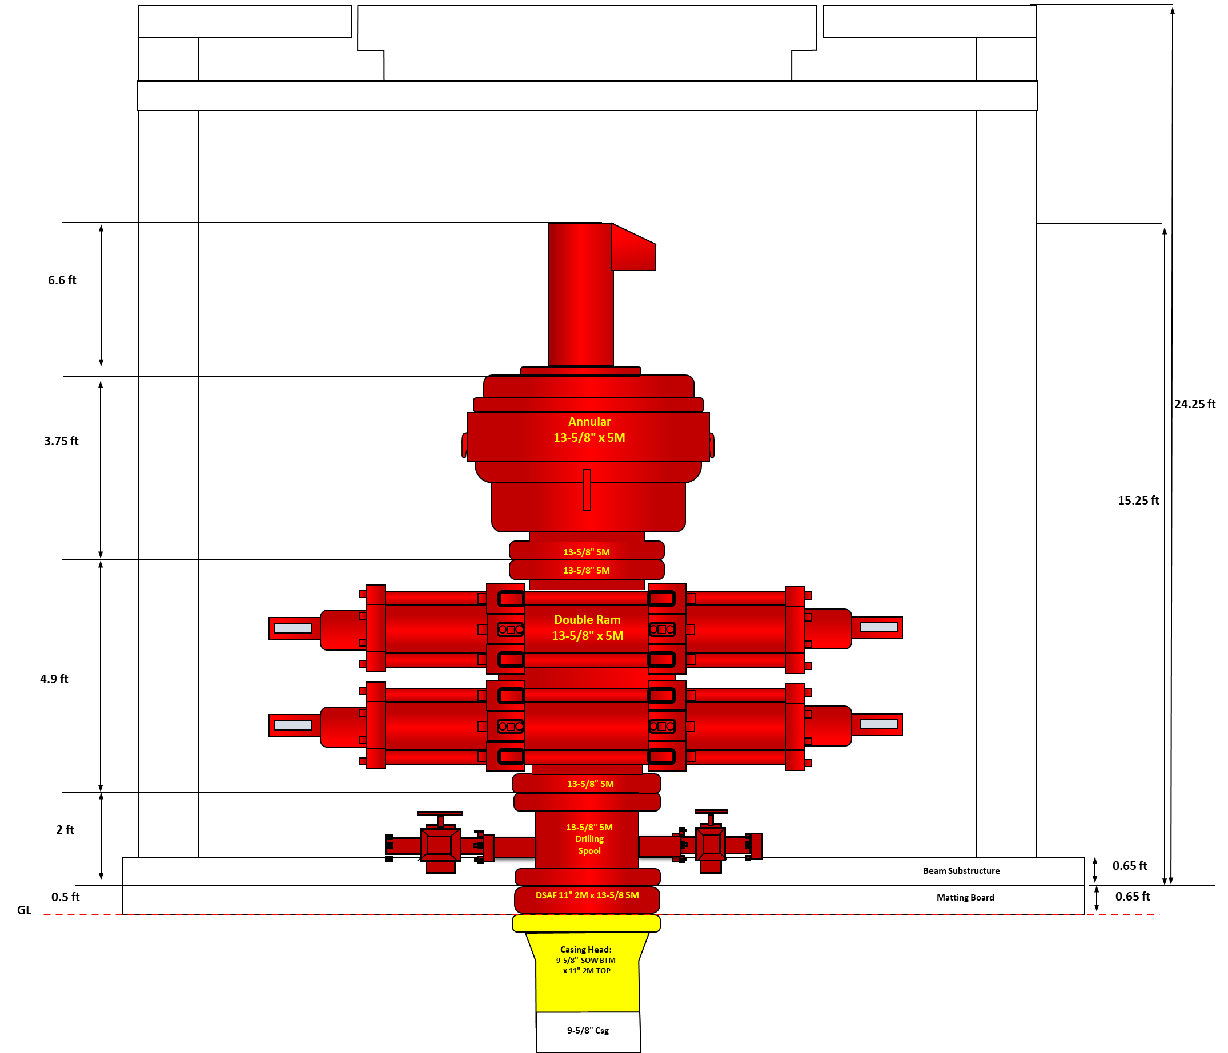
Figure 10.1 BOP Space Out Section A: Casing Head

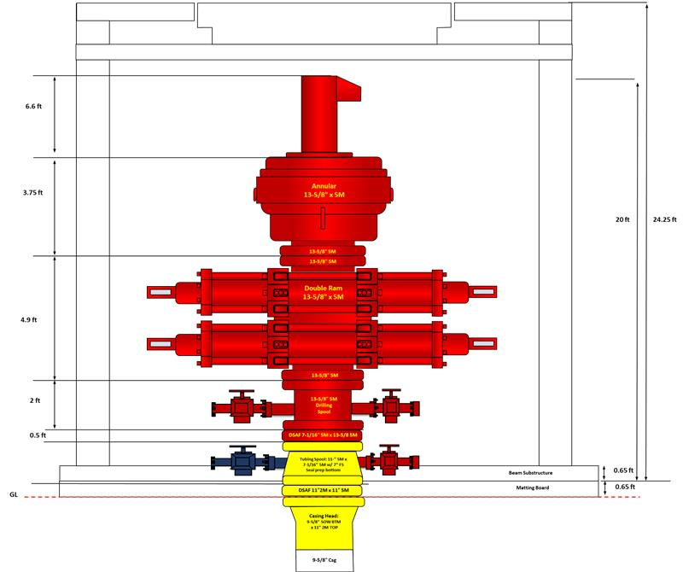
Figure 10.2 BOP Space Out Section B: Tubing Spool

- Choke & Kill Manifold Requirements
The Alpha-07 choke manifold shall have a minimum working-pressure rating of 5,000 psi and shall provide controlled management of wellbore pressure and returns during well-control circulation. The proposed manifold is manufactured by Chengde Kingdream Petroleum Machinery and utilizes 4-1/16 in. gate valves.
The choke system shall include one manual adjustable choke and one remotely operated choke (super choke) to provide operational redundancy and flexibility during well-control operations. The choke line shall utilize a 3 in. Coflex hose suitable for high-pressure flow during well-control circulation.
The kill line shall provide a pressure-rated pumping path into the well during well-control operations. All high-pressure choke and kill lines and associated valves shall have a minimum pressure rating of 5M, consistent with the BOP and choke-manifold system.

Table 10.4 – Alpha-07 Choke & Kill System Specification
Parameter | Alpha-07 Specification
Choke Manifold WP | 5,000 psi (5M)
Manufacturer | Chengde Kingdream Petroleum Machinery
Gate Valve Size | 4-1/16 in.
Manual Choke | 1 × adjustable choke
Remote Choke | 1 × remotely operated super choke
Choke Line | 3 in. Coflex hose
Kill Line | Minimum 5M pressure rating
High-Pressure Lines | Minimum 5M
Primary Function | Controlled well-pressure management and well-control circulation

Figure 10.3 Choke Manifold Configuration

- Wellhead & Xmas Tree Specifications
The Alpha-07 permanent wellhead system shall be selected based on the estimated surface pressure, casing architecture, completion configuration, and anticipated production-fluid environment. Based on the current design basis, the estimated MASP is 938 psi, while the selected permanent wellhead has a Rated Working Pressure (RWP) of 2,000 psi, providing adequate pressure capacity for the expected operating condition.

The selected wellhead system is specified as Class AA, PSL-2, PR-2, 2,000 psi RWP, and Temperature Class U (0°F to 250°F / -18°C to 121°C). The material/service selection is supported by the current expectation of no significant H₂S or CO₂ content and no identified historical corrosion issue in surrounding wells.

The preliminary Alpha-07 wellhead configuration consists of:
- Casing Head: 9-5/8 in. SOW bottom × 11 in. 2M top
- Tubing Spool: 11 in. 2M bottom × 7-1/16 in. 2M top

The wellhead configuration shall provide casing suspension, annular sealing, pressure containment, and the required interface for the drilling BOP and subsequent ESP completion equipment. The tubing spool and upper wellhead arrangement shall be compatible with the planned 3-1/2 in. production tubing and ESP penetrator system.
Table 10.5 Alpha-07 Wellhead Selection & Design Criteria
Parameter | Alpha-07 Design Basis
Estimated MASP | 938 psi
Wellhead RWP | 2,000 psi (2M)
Wellhead Class | AA
PSL | PSL-2
PR | PR-2
Temperature Class | U
Temperature Range | 0°F to 250°F
H₂S / CO₂ | Not expected
Casing Head | 9-5/8 in. SOW × 11 in. 2M
Tubing Spool | 11 in. 2M × 7-1/16 in. 2M
Completion Interface | 3-1/2 in. tubing + ESP penetrator

  - Well Completion & Testing Criteria (If Applicable)
- Completion Design Requirements
Alpha-07 is planned as a cased-hole ESP completion, with the 7 in. production casing cemented across the reservoir section to provide wellbore integrity and zonal isolation. Reservoir access will be established through selective perforation of the approved hydrocarbon-bearing intervals.

The current preliminary perforation window is approximately 4,000–4,500 ft TVDSS, covering the principal target reservoir interval. The final perforation depth and interval selection shall be confirmed based on the final formation-evaluation results, reservoir correlation, fluid-contact interpretation, and Production/Subsurface recommendation prior to completion execution.

The perforation design shall therefore remain flexible at the Basis of Design stage. Final gun size, shot density, phasing, penetration requirement, and firing sequence shall be defined in the dedicated completion/perforation program after the final reservoir interpretation is available.

Table 11.1 – Alpha-07 Completion Design Basis
Parameter | Alpha-07 Design Basis
Completion Type | Cased Hole ESP Completion
Production Casing | 7 in.
Preliminary Perforation Interval | ~4,000–4,500 ft TVDSS
Final Perforation Interval | Based on final formation evaluation and reservoir recommendation
Reservoir Access | Selective perforation
Principal Reservoir Intervals | Principal Reservoir Intervals
Artificial Lift | ESP
Production Tubing | 3-1/2 in., 9.3 ppf, J-55, EUE
Sand Control | Not included in base case unless later required

- Production Tubing & Accessories Criteria (Packer, SSSV)
The Alpha-07 production string shall utilize 3-1/2 in., 9.3 ppf, J-55, EUE tubing as the base-case production tubing. Based on the reference completion program, the tubing has a 2.992 in. ID, 2.867 in. drift diameter, and 4.5 in. coupling OD, with a reference make-up torque of 1,710 / 2,280 / 2,850 ft-lbf (minimum / optimum / maximum).

The ESP specification and Pump Setting Depth (PSD) shall be determined based on the final well-specific Production Engineering design. For Alpha-07, the ESP shall be positioned above the selected perforation interval, with the final PSD determined considering the final perforation depth, expected producing fluid level, required pump submergence, well trajectory, and ESP operating envelope.

The ESP shall be run on the 3-1/2 in. production tubing together with the required power cable and completion accessories. For a directional well, an ESP cable protector shall be installed on each tubing joint. Cable bands shall be installed at two bands per tubing joint for standard ESP cable or three bands per tubing joint when a capillary-tube cable is used. In addition, five cable bands shall be installed on the pup joint immediately above the ESP assembly.

A check valve and bleeder valve shall be installed above the ESP. During RIH, the tubing shall be filled with KCl water every 10 tubing joints to maintain the hydrostatic barrier, compensate for pipe displacement, and provide an indication of tubing integrity. ESP cable electrical integrity shall also be monitored by performing cable reading/megger checks every 20 tubing joints, with any abnormal deviation reported and evaluated before continuing the operation.

The completion shall incorporate an ESP penetrator system through the tubing hanger. The reference completion configuration utilizes a 7-1/16 in. nominal × 3-1/2 in. EUE tubing hanger with ESP penetrator system, providing the interface between the production tubing, ESP cable, and surface wellhead system.

A production packer is not included in the reference base-case ESP completion, and consequently a conventional tubing-string pressure test is not required in the reference program. Alpha-07 shall therefore retain a packerless ESP completion as the preliminary design basis, unless otherwise required by the final well-specific completion design. Following landing of the tubing hanger, pressure integrity of the bottom tubing-hanger seal shall be verified at 500 psi + MASP for 5 minutes, consistent with the reference completion philosophy.

Table 11.2 Alpha-07 ESP & Production String Design Criteria
Parameter | Alpha-07 Design Basis
Production Tubing | 3-1/2 in., 9.3 ppf, J-55, EUE
Tubing ID | 2.992 in.
Tubing Drift | 2.867 in.
Coupling OD | 4.5 in.
Reference MUT | 1,710 / 2,280 / 2,850 ft-lbf (Min./Opt./Max.)
Artificial Lift | ESP
ESP Specification | Based on final Production Engineering design
ESP PSD | Above selected perforation interval; final depth based on PE design
Packer | Not planned – packerless ESP base case
Check Valve | Required above ESP
Bleeder Valve | Required above ESP
Cable Protector | 1 per tubing joint for directional well
Cable Band Above ESP | 5 bands on pup joint above ESP assembly
Cable Reading / Megger Check | Every 20 tubing joints during RIH
Tubing Fill-Up | KCl water every 10 tubing joints during RIH
Tubing Hanger | 7-1/16 in. nominal × 3-1/2 in. EUE
ESP Penetrator | Required through tubing hanger
Conventional Tubing Pressure Test | Not required for reference packerless configuration
Tubing Hanger Seal Test | 500 psi + MASP for 5 min

- Well Testing / Swabbing Requirements
Alpha-07 does not include swabbing or production well testing within the drilling and initial completion scope. The Initial Completion (IC) will be performed using the drilling rig, including perforation and installation of the ESP completion string in accordance with the approved completion program.
Following installation of the ESP and production tubing, the drilling/IC scope shall focus on verification of the completion and pressure integrity, including ESP cable integrity, tubing hanger installation and seal testing, and final wellhead/Xmas Tree installation as applicable.
Upon successful completion of the required integrity verification and confirmation that the well is in a safe and properly secured condition, the well shall be handed over to the Production/Operations team. Subsequent ESP commissioning, well start-up, production testing, and production-performance evaluation are outside the drilling scope and shall be conducted under the applicable Production/Operations procedures.

Table 11.3 Alpha-07 Completion Handover Criteria
Parameter | Alpha-07 Design Basis
IC Execution | By drilling rig
Perforation | Included in IC scope
ESP Installation | Included in IC scope
Swabbing | Not planned
Production Well Testing | Outside drilling scope
ESP Commissioning / Start-Up | Production/Operations scope
Completion Integrity Verification | Required prior to handover
ESP Cable Integrity | Verified during installation
Tubing Hanger / Wellhead Integrity | Verified prior to handover
Final Drilling/IC Objective | Well completed, secured, and ready for handover
Post-Completion | Handover to Production/Operations

  - Well Suspension & Abandonment (P&A) Criteria
- Final Zonal Isolation Criteria (Cement Plugs)
Permanent abandonment of Alpha-07 shall establish effective barriers across all applicable reservoir and potential flow zones. The abandonment design shall consider both vertical and lateral isolation and shall prevent uncontrolled crossflow between formations or migration to surface. The company TKO defines a well barrier/well envelope as the combination of physical barrier elements required to prevent uncontrolled fluid flow between formations or to surface.
For isolation of a perforated interval, the cement plug shall extend through the entire applicable perforated interval and provide a minimum isolation length of 100 ft above and 100 ft below the perforated interval, or extend to the nearest applicable plug. For Alpha-07, this criterion shall be applied to the final producing interval selected from the preliminary ~4,000–4,500 ft TVDSS perforation window, with the actual plug location determined from the final completion condition at the time of abandonment.
Where an open-hole interval requires isolation, the cement barrier shall extend at least 100 ft below to 100 ft above the applicable oil-, gas-, or water-bearing formation. Where open hole exists immediately below a casing shoe, the cement plug shall extend at least 100 ft below and 100 ft above the casing shoe.
A surface cement plug of at least 150 ft shall be installed, with the top of the plug located approximately 150 ft below the applicable surface/mud-line reference, in accordance with the referenced abandonment requirement.
Permanent cement barriers shall be verified prior to acceptance. The reference ASR requirement specifies verification by either a minimum 15,000-lbf load test on an applicable cement retainer/bridge plug or a minimum 1,000-psi pressure test for 15 minutes, as applicable to the barrier configuration. The field ASR plan also uses cement Plug 1, Plug 2, and Plug 3 with verification by 15,000-lbf tag and 1,000-psi pressure test as the reference execution basis.
Table 12.1 Alpha-07 Permanent Abandonment Criteria
Barrier / Parameter | Alpha-07 Design Criterion
Reservoir / Perforation Isolation | Minimum 100 ft above and 100 ft below perforated interval, or to nearest applicable plug
Preliminary Producing Interval | ~4,000–4,500 ft TVDSS; final interval subject to actual completion
Open-Hole Formation Isolation | Minimum 100 ft below to 100 ft above applicable formation
Open Hole Below Casing Shoe | Minimum 100 ft below to 100 ft above casing shoe
Annular Isolation | Cement/isolate applicable annular flow paths
Surface Cement Plug | Minimum 150 ft
Mechanical Plug Verification | Minimum 15,000-lbf load test, where applicable
Cement Plug Pressure Verification | Minimum 1,000 psi for 15 min, where applicable
Number / Final Position of Plugs | Determined by final P&A engineering based on actual well condition
Completion Equipment | Retrieve or incorporate into final barrier design as applicable
Final Requirement | Permanent isolation of potential flow zones and prevention of flow to surface

- Surface Restoration Requirements
Following permanent well abandonment, the Alpha-07 wellsite shall be restored in accordance with the applicable Abandonment & Site Restoration (ASR) requirements. The objective is to remove remaining well and production facilities, eliminate physical obstructions and potential environmental hazards, and restore the site to an agreed final condition.
For an onshore abandoned well, the reference requirement specifies that the wellhead, casing and other remaining well-related obstructions shall be removed to at least 3 ft below ground level, or otherwise in accordance with the prevailing government requirements.
Above-ground facilities associated with the abandoned wellsite, including applicable fencing, piping and other installations, shall be removed. The final condition of the wellsite and access road, including the required extent of restoration, shall be agreed with the relevant company, regulatory, and stakeholder functions.
Site restoration shall include re-grading and re-greening/revegetation as applicable to return disturbed areas to an acceptable condition. The ASR reference specifically includes both well plugging & abandonment and re-greening/revegetation within the well ASR scope.
Table 12.2 – Alpha-07 Surface Restoration Criteria
Item | Alpha-07 Design Criterion
Wellhead Removal | Required after permanent abandonment
Casing / Wellhead Cut-Off | Minimum 3 ft below ground level for onshore well
Surface Equipment | Remove applicable remaining equipment and installations
Flowline / Piping | Remove/decommission in accordance with approved ASR plan
Wellsite | Clean and restore disturbed area
Access / Surrounding Area | Restore as required by final ASR agreement
Waste | Remove and manage in accordance with applicable environmental requirements
Re-grading | As required to restore site condition
Re-greening / Revegetation | Required as applicable
Final Site Condition | Subject to applicable regulatory and stakeholder acceptance

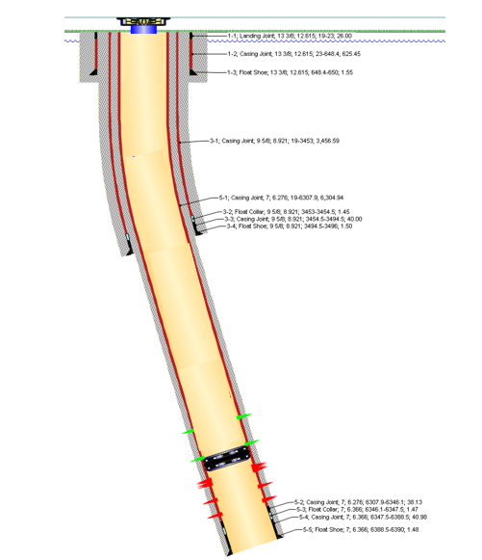 | 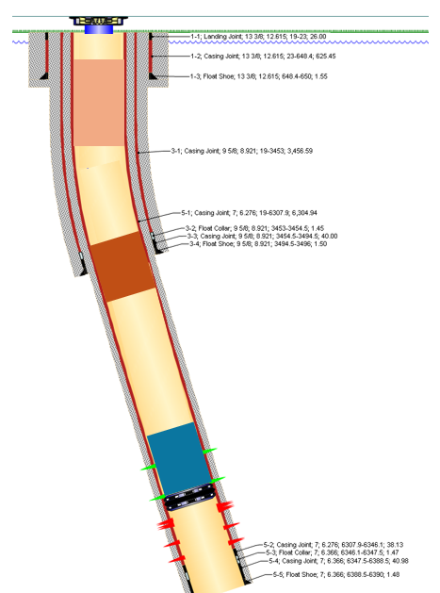
Figure 12.1 Typical Permanent Well Abandonment and Cement Plug Configuration

  - Well Site Preparation Criteria (If Applicable)
    - Soil Bearing Capacity & Pad Footprint Requirements
The Alpha-07 well shall be drilled from a new wellpad designed to accommodate the planned 750 HP land rig, associated drilling equipment, supporting facilities, and the movement of heavy equipment throughout rig mobilization, drilling, completion, and rig demobilization activities. The overall development requires approximately 2–2.5 ha of land for the wellpad and associated supporting facilities.
Prior to final wellpad construction, the ground condition shall be evaluated through the applicable civil/geotechnical site assessment to establish the allowable soil bearing capacity and identify areas requiring ground improvement. The final foundation design shall ensure that the prepared ground can safely support the static and operational loads imposed by the rig substructure, mast, mud system, tanks, tubular storage, and other heavy equipment.
Particular attention shall be given to potential soft-ground conditions and deterioration of access or working surfaces during heavy rainfall, which have been identified as surface execution risks for Alpha-07. Where required, ground improvement, additional compaction, suitable fill material, or composite matting boards at critical ground-contact points shall be incorporated into the final civil design.
The final wellpad footprint shall be developed based on the approved 750 HP rig layout, providing sufficient space for the complete rig package and safe movement of heavy equipment and light vehicles. The Alpha development concept also adopts a cluster wellpad arrangement, with the layout optimized to accommodate potential future wells while minimizing subsequent relocation of flowline and electrical facilities.

Table 13.1 Alpha-07 Wellpad & Ground Design Criteria
Parameter | Alpha-07 Design Basis
Surface Location | New wellpad
Rig Type | 750 HP land rig
Overall Land Requirement | Approximately 2–2.5 ha including supporting facilities
Wellpad Concept | Cluster wellpad / provision for future wells
Soil Bearing Capacity | To be confirmed by civil/geotechnical assessment
Rig Foundation | Designed for actual 750 HP rig loading
Ground Preparation | Compaction / ground improvement as required
Soft Ground Mitigation | Composite matting boards at critical ground-contact points, as required
Drainage / Rainfall Consideration | Required due to potential ground deterioration during heavy rainfall
Equipment Arrangement | Based on approved 750 HP rig layout
HE/LV Movement | Adequate maneuvering and operational clearance shall be maintained
Final Acceptance | Civil/site inspection prior to rig mobilization

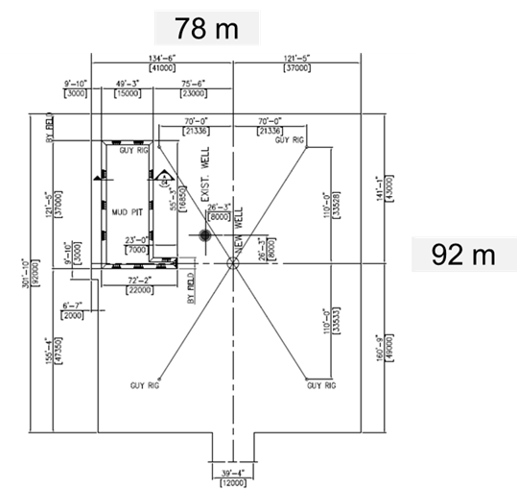
Figure 13.1 Typical 750 HP Rig Wellpad Layout for Alpha-07

    - Cellar & Pre-set Conductor Specifications
The Alpha-07 cellar and pre-set conductor shall be installed as part of the wellsite preparation activities prior to rig mobilization. The cellar shall be constructed at the approved well center in accordance with the final civil/PD drawing and shall provide adequate clearance for conductor installation, subsequent wellhead activities, and drainage during drilling operations.
A 24 in. pre-set conductor consisting of one joint shall be installed prior to rig-up. The conductor shall be driven using a 2-ton drop hammer with approximately 1.5 m ram fall, with installation acceptance based on the applicable Blows per Foot (BPF) criterion. Based on the available conductor-driving reference, a 24 in. pile corresponds to approximately 75-ton bearing capacity, with reference values of 27 BPF at Safety Factor 2.5 and 39 BPF at Safety Factor 3.0.
During conductor driving, the achieved BPF shall be monitored to confirm adequate formation resistance and conductor support. The final driving acceptance criterion shall follow the approved EDT/civil requirement applicable to the Alpha-07 location.

Table 13.2 Alpha-07 Cellar & Pre-set Conductor Criteria
Parameter | Alpha-07 Design Basis
Cellar | Required prior to rig mobilization
Cellar Dimension & Depth | As per approved civil / PD drawing
Cellar Drainage | Required
Pre-set Conductor | 24 in.
Conductor Length | 1 joint
Installation Method | Driven / drop hammer
Hammer Ram Weight | 2 ton
Ram Fall | 1.5 m
Reference Bearing Capacity | 75 ton
Reference BPF – SF 2.5 | 27 BPF
Reference BPF – SF 3.0 | 39 BPF
Driving Acceptance | Based on approved EDT/civil BPF criterion
Final Verification | Conductor integrity, verticality and driving acceptance prior to rig-up

    - Access Road & Bridge Load Bearing Limits
The access road to the Alpha-07 wellsite shall be suitable for mobilization of the 750 HP land rig, heavy equipment, tubulars, tanks, and supporting service units. Prior to rig mobilization, a pre-mobilization road survey shall be completed to verify road condition, geometry, ground condition, road crossings, and any bridge or culvert limitations along the selected mobilization route.
The access road shall be designed and maintained in accordance with the applicable load-bearing requirements for 750 HP rig equipment. Particular attention shall be given to soft-ground conditions, heavy rainfall, and potential road deterioration during rig movement. Where required, road strengthening and composite matting boards shall be provided at critical ground-contact locations to maintain safe passage of heavy equipment.
All bridges and crossings along the rig-move route shall be assessed for both load capacity and dimensional clearance before mobilization. Bridge tonnage capacity and available clearance are specifically identified as potential rig-move constraints and shall therefore be confirmed against the actual transport configuration and maximum equipment load before the route is approved.
Where oversized or heavy-load transportation is required, the applicable heavy-load transport permits and road-crossing clearances shall be obtained in advance. Mobilization through public or community roads shall also incorporate the required traffic-management arrangements, including appropriate escorts and flagmen.

Table 13.3 Alpha-07 Access Road & Bridge Design Criteria
Parameter | Alpha-07 Design Basis
Rig Mobilization Basis | 750 HP land rig
Access Road | Suitable for rig and heavy-equipment mobilization
Road Load Capacity | Designed/verified for actual 750 HP rig transport loads
Pre-Mobilization Road Survey | Required
Soft-Ground Assessment | Required
Heavy-Rain Condition | Considered in road design and mobilization planning
Road Strengthening | As required based on civil assessment
Composite Matting | At critical ground-contact areas as required
Bridge Load Capacity | Verify against maximum actual transport load
Bridge / Crossing Clearance | Verify prior to rig move
Heavy-Load Transport Permit | Required where applicable
Road-Crossing Clearance | Required in advance
Public-Road Traffic Control | Escort / flagmen as applicable
Final Route Acceptance | Prior to rig mobilization

    - Drilling Water Source & Storage Requirements
Drilling water for Alpha-07 may be supplied from multiple approved field water sources, including existing GS standpipe facilities, CMTF, and available field canals, depending on source availability, accessibility, water demand, and operational conditions at the time of execution. The selected water source shall provide sufficient and reliable supply to support drilling activities, including drilling-fluid preparation, cementing support, equipment washing, and general rig utility requirements.
Water intended for drilling-fluid preparation shall be checked prior to use to confirm its suitability and compatibility with the planned KCl-Polymer WBM system. Particular attention shall be given when utilizing canal water due to potential variations in water quality and contamination. Where necessary, the water shall be treated or conditioned prior to mud preparation.
Adequate water storage shall be maintained at the wellsite to support continuous drilling operations and provide sufficient operational buffer against temporary interruptions in water supply. The required storage capacity shall be determined based on the expected operational water demand, mud-system requirement, cementing activities, rig utility consumption, and water replenishment frequency. Alternative approved water sources shall remain available where practicable as contingency in case the selected source becomes unavailable.

Table 13.4 Alpha-07 Drilling Water Source & Storage Criteria
Parameter | Alpha-07 Design Basis
Drilling Water Sources | GS standpipe / CMTF / available field canal
Source Selection | Based on availability, accessibility, water demand and operational condition
Water Quality Check | Required prior to use for mud preparation
Mud Compatibility | Compatible with KCl-Polymer WBM
Canal Water | Water quality shall be verified and conditioned as required prior to use
Main Water Usage | Mud preparation, cementing support, equipment washing and rig utility
Wellsite Water Storage | Adequate storage shall be maintained throughout drilling operations
Storage Capacity Basis | Operational demand, mud/cementing requirement and replenishment frequency
Supply Continuity | Sufficient operational buffer shall be maintained
Contingency | Alternative approved water source may be utilized if required

    - Waste Management & Environmental Pit Specifications
Drilling waste generated during Alpha-07 operations shall be managed in accordance with applicable AMDAL/UKL-UPL and HSSE requirements. Waste handling facilities shall provide adequate containment and prevent contamination of surrounding soil and water throughout drilling and completion activities. The wellsite shall therefore be equipped with a dedicated disposal pit lined with geomembrane for temporary containment of drilling waste fluids.
The disposal pit, geomembrane liner, and associated containment berms shall be maintained in good condition throughout operations. Routine inspection shall be performed to identify potential liner damage, leakage, overflow, or deterioration of the containment system.
Liquid drilling waste and waste mud shall be temporarily collected in the disposal pit and subsequently transported by vacuum truck to the Centralized Mud Treatment Facility (CMTF) for further treatment and disposal. Solid drilling waste/cuttings may be disposed of within the designated disposal pit provided that the applicable metal-content test results are below the allowable threshold.
Other waste generated during operations, including chemical and domestic waste, shall be segregated at source and handled through the appropriate waste-management route according to its classification.
Table 13.5 Alpha-07 Waste Management & Environmental Pit Criteria
Parameter | Alpha-07 Design Basis
Waste Management Basis | Applicable AMDAL / UKL-UPL and HSSE requirements
Disposal Pit | Required
Pit Lining | Geomembrane
Pit Capacity / Dimension | Based on final civil design and expected waste volume
Liquid Drilling Waste | Temporary storage in disposal pit → vacuum truck → CMTF
Solid Drilling Waste / Cuttings | May be buried in disposal pit subject to acceptable metal-content test results
Chemical Waste | Segregated and handled according to applicable waste classification
Domestic Waste | Segregated from drilling and chemical waste
Waste Segregation | Required at source
Pit / Liner Inspection | Daily during operation
Containment Berm | Required and routinely inspected
Spill Prevention | Secondary containment shall be maintained around applicable fluid systems
Final Waste Treatment | CMTF / approved disposal route as applicable
Environmental Objective | Prevent contamination of soil and surrounding water

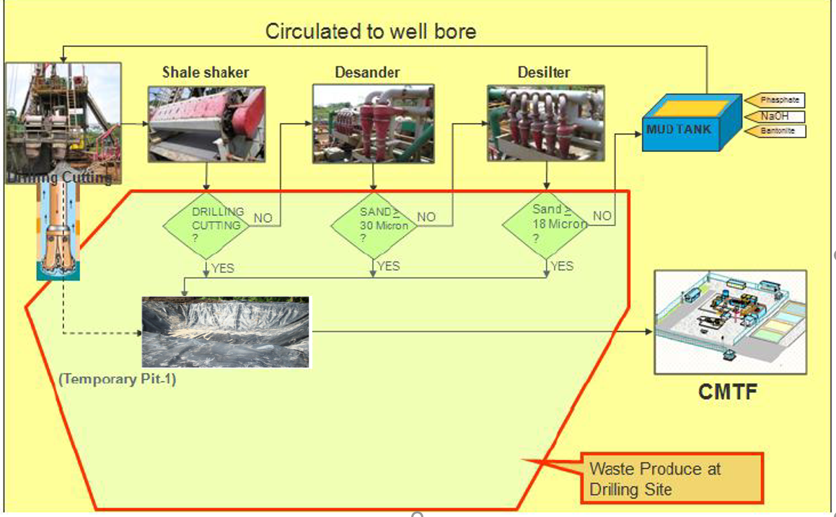
Figure 13.2 Alpha-07 Drilling Waste Handling & Disposal

  - Rig Selection Criteria
- Minimum Hoisting Capacity Requirements
The hoisting system shall provide sufficient capacity to handle the maximum anticipated drillstring and operational loads throughout Alpha-07 execution. Based on the rig capacity calculation, the maximum calculated derrick load is approximately 280,942 lbs, including buoyed drillstring weight, 100,000 lbs maximum overpull allowance, and 30,000 lbs block and TDS weight.
The calculated minimum drawworks power requirement is approximately 568 HP. Accordingly, the selected 750 HP rig provides sufficient hoisting capacity and power margin for the planned Alpha-07 well.

Table 14.1 Alpha-07 Hoisting Capacity Design Basis
Parameter | Alpha-07 Design Basis
Planned TD | 5,312 ft MD
Maximum Overpull Allowance | 100,000 lbs
Block + TDS Weight | 30,000 lbs
Buoyed Drillstring Weight | 152.340 lbs
Maximum Derrick Load | 282.340 lbs
Calculated Drawworks Power Required | 570 HP
Selected Rig | 750 HP Land Rig
Hoisting Efficiency | 90%
Hoisting Speed Basis | 60 ft/min

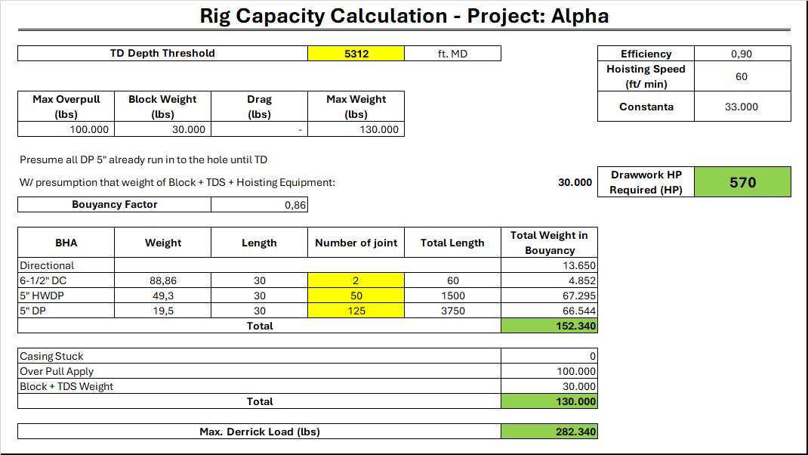
Figure 14.1 Alpha-07 Rig Hoisting Capacity Calculation

- Mud Pump & Solid Control System Specifications
The rig circulating system shall provide sufficient hydraulic capacity for the planned Alpha-07 drilling program, including the 12-1/4 in. and 8-1/2 in. hole sections. The rig is equipped with three F-1000 mud pumps, each rated at 1,000 HP, with a maximum pump speed of 140 SPM and maximum discharge pressure of 5,000 psi.
For Alpha-07, the mud pumps are planned to utilize 6 in. liners with 12 in. stroke as the operating configuration. The selected liner shall provide sufficient flow rate and pressure capacity to meet the hydraulic requirements of both hole sections. Actual pump operating rate and number of pumps in service shall be adjusted according to the required flow rate and SPP while maintaining adequate operating margin within the pump and surface circulating system limits.
The solids-control system shall provide sufficient capacity to process the circulating drilling fluid and effectively control drilled solids. The system includes shale shakers, desander, desilter, and vacuum degasser. The shale shaker is rated up to 600 GPM per unit, subject to mud properties, with available screens ranging from Mesh 80 to 200. The desander consists of 2 × 12 in. cones with a feed rate of 500 GPM, while the desilter consists of 16 × 4 in. cones. The vacuum degasser has a rated flow capacity of 950 GPM.
Table 14.2 Alpha-07 Rig Specification
Parameter | Rig Specification / Design Criterion
Mud Pump | 3 × F-1000
Rated Power | 1,000 HP per pump
Maximum Pump Speed | 140 SPM
Maximum Discharge Pressure | 5,000 psi
Maximum Liner × Stroke | 6-1/4 in. × 12 in.
Volumetric Efficiency | 97%
Shale Shaker Capacity | Up to 600 GPM/unit*
Available Shaker Screens | Mesh 80, 100, 120, 140
Desander | 2 × 12 in. cones; 500 GPM
Desilter | 16 × 4 in. cones
Vacuum Degasser | 950 GPM
Operational Requirement | Meet Alpha-07 hydraulic flow rate and SPP requirements

- Power Requirements & Drive System
Alpha-07 shall be drilled using a 750 HP land rig equipped with a Top Drive System (TDS). The rig power system shall provide sufficient capacity to support the planned drilling operations, including hoisting, mud circulation, rotary drilling, directional drilling, reaming/backreaming, hole conditioning, and associated auxiliary equipment. The available electrical system consists of three main generator sets rated at 1,200 kW each.
The rig is equipped with a DQ40 Top Drive System with a rated hoisting capacity of 250 ton and rotary speed capability of 0–180 rpm. The TDS provides 28.5 kN·m (21,200 lbf·ft) continuous drilling torque and 47 kN·m (34,600 lbf·ft) maximum breakout and brake torque. The TDS is equipped with a 3 in. mud flow path rated to 5,000 psi circulating pressure and is capable of handling drill pipe sizes from 2-7/8 in. to 5-1/2 in., covering the planned 5 in. drillstring for Alpha-07.
The Top Drive System shall provide adequate operational flexibility to maintain rotation and circulation during drilling and applicable hole-conditioning operations, including reaming and backreaming where required. Predicted drilling and backreaming torque shall remain within the TDS and drillstring torsional limits, while maximum operating SPP shall remain below the applicable TDS and surface circulating-system pressure ratings.
Table 14.3 Alpha-07 Power Requirements & Drive System
Parameter | Rig Specification
Rig Rating | 750 HP
Main Generator | 3 × 1,200 kW
Drive System | Top Drive System (TDS)
TDS Model | DQ40
Rated Hoisting Capacity | 250 ton
Maximum Static Hookload | 404,656 lbs
Max Driller To Pull | 183,5 Ton
Rotary Speed Range | 0–180 rpm
Continuous Drilling Torque | 28.5 kN·m (21,200 lbf·ft)
Maximum Breakout Torque | 47 kN·m (34,600 lbf·ft)
Maximum Brake Torque | 47 kN·m (34,600 lbf·ft)
TDS Mud Path | 3 in.
TDS Circulating Pressure | 5,000 psi
Drill Pipe Handling Range | 2-7/8 – 5-1/2 in.
Planned Alpha-07 Drillstring | 5 in. DP / HWDP
Operational Capability | Drilling, rotating/circulating, reaming/backreaming and hole conditioning

  - General Operational Sequence
Short Moving (Intra Field):
Phase | Main Operational Sequence | Planned Depth | Duration (Days) | Cumulative Days
Moving In – Rigging Up | Rig mobilization, positioning, rig-up and preparation of drilling equipment | – | 6.00 | 6.00
Preparation | Final wellsite/rig readiness, pre-spud preparation, conductor and drilling preparation activities | ~90 ft | 0.43 | 6.43
Drilling Surface Section | Drill 12-1/4 in. hole to planned surface casing depth | ~1,800 ft MD | 1.30 | 7.73
Flat Time Surface Section | CHC, POOH/L/D BHA, RIH 9-5/8 in. casing, cementing, wellhead installation, N/U BOP, S/U string and drill-out preparation | ~1,800 ft MD | 2.94 | 10.67
Drilling Production Section | Drill 8-1/2 in. directional hole to planned production TD | ~5,000 ft MD | 2.95 | 13.62
Flat Time Production Section | Final CHC, POOH/L/D BHA, OH logging, RIH 7 in. casing, cementing, WOC, N/D BOP and final wellhead installation | ~5,000 ft MD | 5.76 | 19.38
Initial Completion | CBL, perforation, RIH production tubing and ESP completion | ~5,000 ft MD | 1.92 | 21.30
Drilling + IC Only | Excluding moving | – | 15.30 | –
Total Well Cycle Including Moving | Moving + drilling + initial completion | – | 21.30 days

Long Moving (Inter Field):
Phase | Main Operational Sequence | Planned Depth | Duration (Days) | Cumulative Days
Moving In – Rigging Up | Rig mobilization, positioning, rig-up and preparation of drilling equipment | – | 6.00 | 14.00
Preparation | Final wellsite/rig readiness, pre-spud preparation, conductor and drilling preparation activities | ~90 ft | 0.43 | 14.43
Drilling Surface Section | Drill 12-1/4 in. hole to planned surface casing depth | ~1,800 ft MD | 1.30 | 15.73
Flat Time Surface Section | CHC, POOH/L/D BHA, RIH 9-5/8 in. casing, cementing, wellhead installation, N/U BOP, S/U string and drill-out preparation | ~1,800 ft MD | 2.94 | 18.67
Drilling Production Section | Drill 8-1/2 in. directional hole to planned production TD | ~5,000 ft MD | 2.95 | 21.62
Flat Time Production Section | Final CHC, POOH/L/D BHA, OH logging, RIH 7 in. casing, cementing, WOC, N/D BOP and final wellhead installation | ~5,000 ft MD | 5.76 | 27.38
Initial Completion | CBL, perforation, RIH production tubing and ESP completion | ~5,000 ft MD | 1.92 | 29.30
Drilling + IC Only | Excluding moving | – | 15.30 | –
Total Well Cycle Including Moving | Moving + drilling + initial completion | – | 29.30 days

  - Technical Risk Management
- Technical Risk Register
Technical risk management for Alpha-07 shall focus on the principal subsurface and operational risks that may affect wellbore integrity, drilling performance, ability to reach planned TD, casing and logging operations, and overall well delivery. The key subsurface hazards identified for Alpha-07 include reactive clay/gumbo, sloughing shale, tight hole, loss circulation, differential sticking, casing stop, and logging stop. The reservoir sandstone intervals are particularly associated with loss-circulation risk, while the overlying shale-dominated intervals present the main wellbore-instability risks.
The technical risk-management approach shall combine preventive well design, hydraulic and torque-and-drag modelling, appropriate drilling-fluid properties, real-time drilling surveillance, hole-conditioning practices, and predefined contingency actions. Risk status shall be reviewed throughout execution and the operating parameters adjusted according to actual well response.

Table 16.1 Alpha-07 Technical Risk Register
Technical Risk | Expected Interval / Condition | Potential Impact | Initial Risk | Key Mitigation / Contingency
Reactive Clay / Gumbo | Shale-dominated upper interval | Bit/BHA balling, reduced ROP, poor hole cleaning, tight hole | M | KCl-Polymer inhibition; maintain mud properties; monitor cuttings and shaker condition
Sloughing / Wellbore Instability | Upper shale intervals | Cavings, fill, pack-off, high drag/overpull, stuck pipe | M | Develop MW vs. depth basis; monitor cavings; increase MW as well dictates; maintain inhibition and hole cleaning
Tight Hole / Excessive Drag | Open-hole sections, particularly after static exposure | High pickup weight/overpull, difficult trip, inability to run casing/logging tools | M | Monitor P/U, S/O and rotating weight against T&D baseline; circulate/condition hole; wiper trip where required
Loss Circulation – Drilling | Deeper sandstone/reservoir intervals | Partial/total losses, reduced hydrostatic head, well-control exposure, formation damage | H | Control ECD; maintain effective hole cleaning; HiVis sweeps; preventive LCM/fiber; loss contingency available
Loss Circulation – Cementing | Production/reservoir interval | Inadequate cement placement, reduced TOC/zonal isolation, remedial cementing | H | Manage ECD during placement; loss-prevention material/fiber as applicable; lightweight cement where required; prepare top-job contingency
Differential Sticking | Permeable reservoir intervals under overbalance and static condition | Stuck drillstring, fishing, NPT | H | Fluid-loss control; bridging material; minimize stationary time; monitor ECD/T&D; maintain string movement where practicable
Pack-off / Poor Hole Cleaning | High solids loading or deteriorating hole condition | SPP increase, torque/drag increase, stuck pipe and losses due to elevated ECD | M | Maintain adequate flow rate; monitor SPP/ECD and cuttings return; HiVis sweep and dedicated circulation as required
Logging Stop / Stuck Logging Tool | Production open hole | Incomplete formation evaluation, additional trip/fishing/NPT | M | Good final hole conditioning; conditioning trip if required; prepare alternative conveyance/logging method if tool cannot reach target
Casing Stop | 9-5/8 in. and particularly 7 in. casing run | Casing unable to reach planned setting depth; remedial operation/NPT | M | Good hole cleaning and mud properties; evaluate hole condition before casing; wiper trip where required; casing swedge/circulation contingency
MWD / Directional Tool Failure | Directional drilling sections | Loss of directional control, trajectory deviation, additional trip | M | Shallow function test; verify motor/MWD before drilling ahead; backup tool readiness and escalation procedure
Rig / Critical Equipment Failure | Throughout drilling | Loss of circulation/hoisting capability, NPT and potential well-control exposure | M | Pre-spud inspection/acceptance; preventive maintenance; critical spare parts available
Well Control / Influx | Particularly permeable reservoir interval | Loss of primary well barrier and well-control event | H | Maintain appropriate overbalance; continuous flow/pit monitoring; certified/tested BOP and pressure-control equipment; maintain required well barriers

- Initial Design Mitigation Strategies
The initial Alpha-07 well design incorporates technical mitigation measures intended to reduce the probability and consequence of the identified drilling risks before execution. These measures shall form the baseline operating envelope and shall be refined in the final Drilling Program based on the latest offset-well information, service-company simulations, and actual field conditions.

Table 16.2 Alpha-07 Initial Design Mitigation Strategies
Design Area | Initial Mitigation Strategy
Well Architecture | Two-string design with 9-5/8 in. surface casing and 7 in. production casing to isolate the upper interval before drilling the deeper reservoir section
Mud System | KCl-Polymer WBM selected to provide shale inhibition and control reactive clay/gumbo
Mud Weight | Maintain MW within the established PP–FG operating window and adjust based on actual wellbore response
Wellbore Stability | Monitor cavings, cuttings shape, drag, fill and SPP trends as early indicators of deteriorating hole condition
Loss Prevention | Maintain ECD below applicable formation integrity limit; preventive LCM/fiber available for loss-prone reservoir intervals
Hole Cleaning | Maintain adequate flow rate and rheology; apply HiVis sweeps and dedicated circulation when hole-cleaning indicators deteriorate
Hydraulics | Monitor flow rate, SPP, ECD, HSI and bit hydraulics against the planned hydraulic operating envelope
Torque & Drag | Establish predicted P/U, S/O, rotating weight, hookload and torque baseline; compare actual values against the T&D envelope
Differential Sticking | Maintain fluid-loss control and bridging material; minimize unnecessary stationary time, particularly in permeable production intervals
Directional Control | Use mud motor + MWD BHA with controlled dogleg; minimize unnecessary corrections through the tangent section
Survey Practice | Acquire surveys preferentially before planned connections to minimize additional static exposure
Logging Readiness | Perform adequate final hole conditioning prior to logging; conditioning trip and alternative logging conveyance available if required
Casing Running | Confirm acceptable casing-running T&D; maintain good hole condition before casing; wiper trip/circulation contingency available
Cementing | Design placement to maintain ECD within formation limit; loss-mitigation and remedial cementing contingency available
Well Control | Maintain overbalanced drilling and continuous pit/flow monitoring; pressure-control equipment tested before drilling ahead
Equipment Reliability | Pre-spud function and acceptance testing of critical rig, mud-pump, BOP, MWD/motor and supporting systems
The main mitigation philosophy for sloughing is to establish the mud-weight-versus-depth basis from offset performance, monitor cuttings returns for early indications of instability, and increase mud weight where dictated by actual hole condition. For loss circulation, ECD control, effective hole cleaning, HiVis sweeps, LCM/fiber and cementing contingency are identified as the principal controls.
For differential sticking, the design emphasizes fluid-loss control, bridging material, reduction of stationary pipe time during connections and surveys, ECD/hole-cleaning surveillance, T&D monitoring, and securing the drillstring inside casing where an extended operational shutdown is anticipated.
For casing and logging accessibility, final hole condition becomes the principal acceptance criterion before proceeding. The contingency includes wiper/conditioning trips and casing circulation capability, while repeated logging-tool stop may require an alternative logging conveyance method.

  - Detail Time Line & Cost
    - Target Schedule
The Alpha-07 development schedule covers both pre-spud project readiness activities and well execution. The pre-spud schedule is structured through sequential sanction, engineering, regulatory, contracting, and execution-readiness phases, with the overall objective of achieving Spud Authorization in Q4 2026.
The project has progressed through the initial Gate-1 and engineering activities, including the development of the Basis of Design, well trajectory, casing and mud design, directional planning, and procurement preparation. Regulatory and contracting activities are subsequently progressed in parallel to ensure that all technical, commercial, permitting, site, and equipment-readiness requirements are closed prior to rig mobilization.
Table 17.1 Alpha-07 Project Readiness & Target Schedule
Phase | Target Period | Key Activities | Current Remarks
Phase 1 – Gate 1 | June 2026 | VBWO submission, Gate-1 sanction, AFE authorization | Completed / passed
Phase 2 – Engineering | July 2026 | BOD finalization, directional plan & anti-collision review, ESP specification/order, LLI procurement | Engineering substantially progressed; final BOD closure ongoing
Phase 3 – Regulatory | July 2026 | PTD submission, environmental permit confirmation, land clearance (LI/LER) | Regulatory readiness progressed in parallel; final closure subject to respective approvals
Phase 4 – Contracting | August 2026 | Rig confirmation, tender launch, PTD approval, contract award, site preparation, LLI delivery confirmation | Current project phase – contracting and execution-readiness activities in progress
Phase 5 – Pre-Spud | Sep–Oct 2026 | Gate-2 sign-off, pre-spud meeting, rig mobilization, BOP test & certification | Upcoming – subject to closure of engineering, permits, contracts, site and LLI readiness
Spud Authorization | Q4 2026 | Confirmation that all technical, regulatory and operational readiness requirements are satisfied | Target milestone

As of August 2026, Alpha-07 is positioned within Phase 4 – Contracting and execution readiness, with activities focused on rig confirmation, service contracting, regulatory approval, site preparation, and confirmation of long-lead-item availability. These activities are planned to converge into the Phase 5 – Pre-Spud stage, during which Gate-2 approval, pre-spud coordination, rig mobilization, and final pressure-control equipment readiness will be completed. Spud Authorization is targeted for Q4 2026, subject to closure of all applicable engineering, regulatory, contracting, site, and operational readiness requirements.

Table 17.2 Alpha-07 Well Execution Target Schedule
Phase | Duration (Days)
Long Moving & Rig Up | 14.00
Short Moving & Rig Up | 6.00
Preparation | 0.43
Drilling Surface | 1.30
Flat Time Surface | 2.94
Drilling Production | 2.95
Flat Time Production | 5.76
Initial Completion | 1.92
Drilling + Initial Completion | 15.30
Total Well Cycle – Short Move | 21.30
Total Well Cycle – Long Move | 29.30

    - Conceptual Cost Estimate
The conceptual cost estimate for Alpha-07 has been developed based on the planned well design, drilling and completion sequence, required materials, rig and service requirements, and the anticipated duration of each operational phase.
The current estimated total well cost for Alpha-07 is approximately USD 1.78 million, consisting of approximately USD 0.42 million tangible cost and USD 1.36 million intangible cost. The estimate covers the principal drilling and completion scope, including rig and associated services, drilling and directional services, drilling fluids, casing and tubulars, cementing, logging and wireline, wellhead equipment, completion and ESP, logistics, waste management, and other supporting services required for well execution.
Table 17.3 Alpha-07 Conceptual Cost Estimate for Short Moving
Cost Component | Conceptual Cost
Tangible Cost | USD 422,090
Intangible Cost | USD 1,357,520
Total Conceptual Well Cost | USD 1,779,610

Table 17.3 Alpha-07 Conceptual Cost Estimate for Long Moving
Cost Component | Conceptual Cost
Tangible Cost | USD 422,090
Intangible Cost | USD 1,551,710
Total Conceptual Well Cost | USD 1,973,800

    - Days vs Depth Curve
The Days vs Depth (DVD) curve for Alpha-07 has been developed using the drilling performance of Alpha-01 to Alpha-06 as offset references. The curve provides a time-versus-depth benchmark for the planned well and is used to establish the expected drilling and flat-time performance for each major operational phase.
Based on the proposed Alpha-07 schedule, the well is planned to progress through the surface section to approximately 1,800 ftMD, followed by the production section to approximately 5,000 ftMD. The planned duration from preparation through initial completion is approximately 15.30 days, excluding rig moving activities.
The Alpha-07 DVD profile is divided into the following major phases:
Table 17.4 Alpha-07 Days vs Depth (DVD) Target Schedule
Phase | Target Depth | Duration (Days) | Cumulative Duration*
Preparation | ~90 ftMD | 0.43 | 0.43
Drilling Surface | ~1,800 ftMD | 1.30 | 1.73
Flat Time Surface | ~1,800 ftMD | 2.94 | 4.67
Drilling Production | ~5,000 ftMD | 2.95 | 7.62
Flat Time Production | ~5,000 ftMD | 5.76 | 13.38
Initial Completion | ~5,000 ftMD | 1.92 | 15.30
*Excluding rig moving.
Comparison with the Alpha Field offset wells indicates that the proposed Alpha-07 performance is generally within the historical drilling-performance envelope. The DVD curve shall therefore be used as the initial execution benchmark for monitoring actual drilling progress against the planned schedule. During execution, actual days versus depth shall be tracked to identify deviations in drilling performance, flat time, or completion duration and to support timely operational improvement.
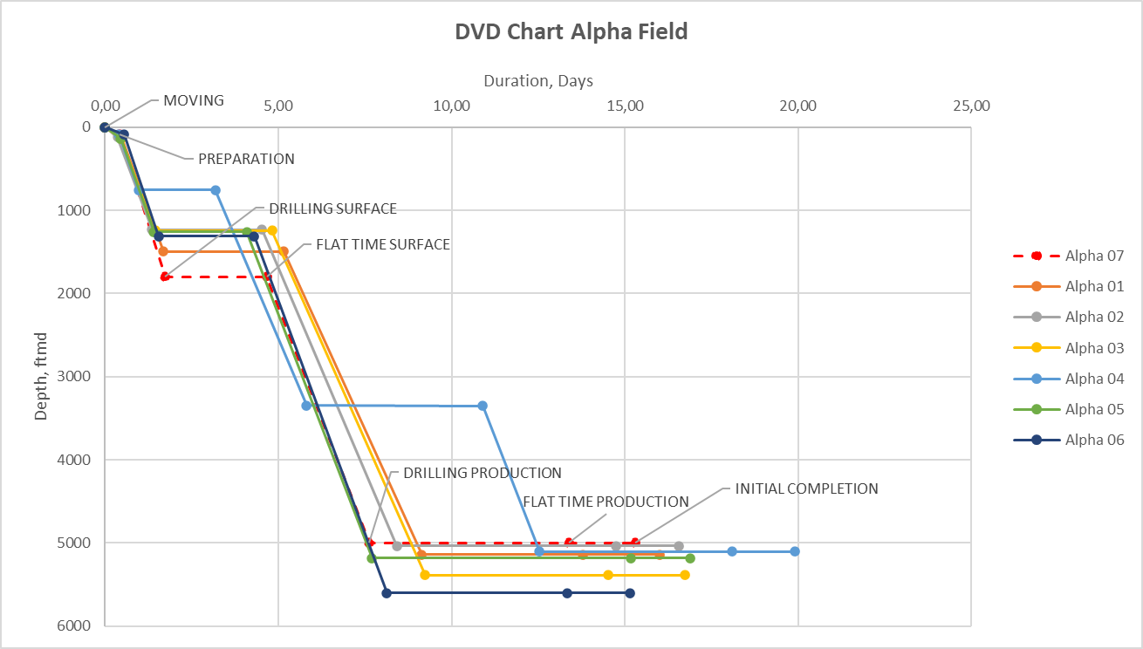
Figure 17.2 Alpha-07 Days vs Depth Curve and Offset Well Comparison

  - Document Requirements & Approvals
- References & Supporting Documents
TBC

- BOD Approval Workflow (Sign-off: Drilling, Subsurface, Facilities, Assets)
The Alpha-07 BOD shall be prepared by a multidisciplinary project team covering Drilling Engineering, Subsurface, Facilities/HSE, and Project Integration. All project team members shall provide sign-off as confirmation of their contribution to and alignment with the technical basis presented in the BOD.

Table 18.2 Alpha-07 BOD Preparation Team
No. | Name | Discipline / Responsibility
1 | Abrar Laylramadhan | Drilling Engineering
2 | Bernard Cavin Ronlei Sihombing | Drilling Engineering
3 | Adriansyah Andra Kusuma | Drilling Engineering
4 | Nyoman Prema Ananda | Drilling Engineering
5 | Salman Arkan | Drilling Engineering
6 | Asri Permatasari Sirait | Subsurface
7 | Abdi Surya | Subsurface
8 | Hana Malem Karina Panjaitan | Facilities
9 | Shanaz Ivona Dewi Limaran | Facilities / HSE
10 | Muhammad Hammam Reza | Project Integration

Table 18.3 Alpha-07 BOD Preparation Team Sign-Off
Name | Discipline / Responsibility | Signature | Date
Abrar Laylramadhan | Drilling Engineering
Bernard Cavin Ronlei Sihombing | Drilling Engineering
Adriansyah | Drilling Engineering
Nyoman Prema Ananda | Drilling Engineering
Salman Arkan | Drilling Engineering
Asri Permatasari Sirait | Subsurface
Abdi Surya | Subsurface
Muhammad Hammam Reza | Subsurface
Hana Malem Karina Panjaitan | Facilities
Shanaz Ivona Dewi Limaran | Facilities / HSE

